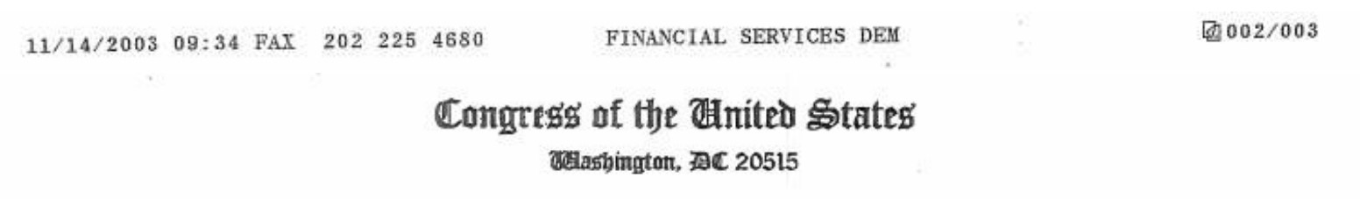

November 13, 2003
Honorable Mel Martinez
Secretary
Department of Housing and Urban Development
451 7th Street, SW
Washington, DC 20410
Dear Secretary Martinez:
We are writing to express our deep disappointment in HUD’s July 17 rejection of the Manufactured Housing Consensus Committee recommendation, which addresses the problem in the siting of manufactured homes. We ask HUD to use its expanded authority under the “Manufactured Housing Improvement Act of 2000” to address this growing problem, which is undermining homeownership opportunities for low-income and minority Americans.
The Millennial Housing Commission concluded that “During the 1990s, manufactured housing placements accounted for one quarter of all housing starts and, from 1997 to 1999, 72 percent of new units affordable to low income homebuyers.” Unfortunately, discrimination in the siting of manufactured homes continues to undermine its full potential to meet the needs of low-income homebuyers. A September 2002 Ford Foundation study on manufactured housing noted that “zoning and code rules continue to be a major barrier,” and that “the vast majority of local governments continue to discriminate against manufactured housing, thereby limiting its potential to meet the needs for affordable housing.”
You have made homeownership a top Administration priority, emphasizing opportunities for low-income Americans. You have also made reducing local barriers to affordable home ownership a top priority announcing on June 10th a Department-wide effort to break down such barriers, in order to create “an environment to increase minority homeownership.”
The very first recommendation of the Manufactured Housing Consensus Committee addressed the problem of discrimination against localities enforcing discriminatory covenants made by private landowners. We believe HUD’s summary rejection of this proposal is inconsistent with HUD’s stated priority of removing barriers to affordable low-income homeownership opportunities.
We understand that HUD may have concerns about its legal authority to implement this particular proposal. But, we believe that HUD should have taken this opportunity to use its expanded legal preemption authority under the 2000 Act to develop a Policy Statement or regulation to make it clear that localities may not engage in discriminatory practices that unfairly inhibit or prohibit development and placement of manufactured housing. We understand that some in the industry have asked HUD to take action and we urge HUD to be responsive to this request.

Page Two
We are also troubled by the legal analysis HUD used in its July 17th rejection of the Consensus Committee recommendation. HUD’s analysis relies on rulings in cases that predated the 2000 Act amendments, which render such rulings obsolete. Moreover, HUD’s legal analysis states that the 2000 Act amendments “did not modify the basic substance of the statutory preemption provision.” Such a statement ignores the plain language of the 2000 Act changes.

Prior to the 2000 Act changes, the statute merely prohibited states and localities from establishing any standard regarding construction or safety “applicable to the same aspect of performance of such manufactured home which is not identical to the Federal manufactured home construction and safety standard.” The 2000 Act broadened this provision to add that: “Federal Preemption under this subsection shall be broadly and liberally construed to ensure that disparate State or local requirements or standards do not affect the uniformity and comprehensiveness of the standards promulgated under this section nor the Federal superintendence of the manufactured housing industry established by this title.”

The 2000 Act amendments also expanded the findings and purposes of the Act. Prior to 2000, the statutory findings declared it necessary to establish construction and safety standards merely to “reduce the injuries, deaths, insurance and property damage,” and “to improve the quality and durability of manufactured homes.” The 2000 Act amendments introduced the new findings that “manufactured housing plays a vital role in meeting the housing needs of the nation” and that “manufactured homes provide a significant resource for affordable home ownership.” New purposes were also introduced by the 2000 Act, which includes protecting the “affordability of manufactured homes,” and “facilitating the availability of affordable manufactured homes and to increase homeownership for all Americans.”
Thus, the 2000 Act expressly provides, for the first time, for “Federal preemption,” and states that this should be “broadly and liberally construed” to ensure that local “requirements” do not affect “Federal superintendence of the manufactured housing industry.” Combined with the expansion of the findings and purposes of the Act to include for the first time the “availability of affordable manufactured homes,’ the 2000 Act changes have transformed the Act from solely being a consumer protection law to also being an affordable housing law.
More specifically, these combined changes have given HUD the legal authority to preempt local requirements or restrictions which discriminate against the siting of manufactured homes (compared to other single family housing) simply because they are HUD-code homes. We ask that HUD use this authority to develop a Policy Statement or regulation to address this issue, and we offer to work with you to ensure that it comports with Congressional intent.
Sincerely,
