United States Government Accountability Office

Report to Congressional Requesters



July 2014 | MANUFACTURED HOUSING  Efforts Needed to  Enhance Program  Effectiveness and  Ensure Funding  Stability
GAO-14-410

July 2014
MANUFACTURED HOUSING
Efforts Needed to Enhance Program Effectiveness and Ensure Funding Stability
What GAO Found
HUD has established a process for updating the preemptive building standards for manufactured homes known as the HUD Code but has not fully met key purposes of the 2000 Manufactured Housing Improvement Act (2000 Act). Key purposes of the Act include:

Highlights of GAO-14-410, a report to congressional requesters
Why GAO Did This Study
Manufactured housing traditionally has been a low-cost option in the U.S. housing market. For nearly 40 years, HUD has provided standards for the manufactured housing industry by developing and updating the HUD Code. The 2000 Act was intended, among other things, to establish a balanced consensus process for updating the standards and regulations for enforcing them and to encourage manufactured housing as an affordable option. GAO was asked to study HUD’s implementation of the 2000 Act.
This report addresses, among other things, the extent to which HUD has met key purposes of the 2000 Act and assesses whether user fees cover program costs. GAO interviewed and collected data for 2000-2013 from HUD, other agencies, and industry groups. GAO also visited large and small plants that built manufactured housing to solicit industry perspectives.
What GAO Recommends
GAO makes several recommendations, including that HUD develop and implement a plan for updating construction and safety standards in a timely fashion; develop a plan to assess how FHA financing might further manufactured home affordability; complete label fee rulemaking; and assess the need for other user fees. Of these, HUD agreed with the first recommendation and partially agreed with the next two because it believes it has already taken actions. HUD stated it would consider the last recommendation. GAO continues to believe these recommendations remain valid as discussed in the report.

View GAO-14-410. For more information, contact Mathew J.Scirè at (202) 512-8678 or sciremj@gao.gov.
- Establish a balanced, consensus-based process to update manufactured housing construction and safety standards. HUD has not accepted, rejected, or modified any of the Manufactured Housing Consensus Committee’s recommendations for updating the HUD Code within 1 year of their submission. The 2000 Act requires HUD to act on the committee’s recommended standards within 1 year if they were submitted in the form of a proposed rule with an economic analysis. According to HUD, because the committee did not include economic analyses in the proposals, HUD staff performed this task. They also stated because the proposals lacked the analyses, the Act’s 1-year timeline was not triggered. In some cases, HUD has not decided on recommendations made more than a decade ago and lacks a plan to address the backlog. Meanwhile, some states’ and localities’ residential building codes require standards not in the HUD Code, resulting in post-production upgrades that may increase costs to homeowners. Not updating the HUD Code delays its intended benefit—to improve the quality, durability, safety, and affordability of manufactured homes.
- Facilitate the availability of affordable manufactured homes. Owners of manufactured homes have lower monthly housing costs than site-built owners and apartment renters, but high financing costs often keep these homes from being even more affordable. HUD’s Federal Housing
Administration (FHA) has two insurance programs for manufactured home loans. Although most manufactured homes are titled or owned as personal property, HUD’s programs primarily insure loans on manufactured homes financed as real estate. Additionally, owners of manufactured homes are more likely to have higher-priced financing than owners of site-built homes. The 2000 Act required HUD to review the effectiveness of the FHA programs, but HUD has not developed a plan to do so. Such research would help HUD determine whether and how it might further facilitate the availability of affordable manufactured homes.
The 2000 Act establishes HUD’s authority to collect fees for certification labels on manufactured homes built to the HUD Code. The fees are placed in the Manufactured Housing Fees Trust Fund that provides annual appropriations to fund the expenses of the Manufactured Housing Program. The current fee rate does not produce sufficient collections to fully fund the program’s expenses and must be supplemented by annual appropriations from Treasury’s General Fund. HUD has indicated its intent to raise the label fee, which currently stands at $39. As we provided a draft of this report, HUD issued a proposed rule to increase the label fee, but has not yet completed the rulemaking process. It has also not fully assessed the feasibility and benefits of putting in place other fees authorized by recent appropriation acts, in part, because it has carryover balances from past years. Without more fee revenue, however, the program will continue to require Treasury’s General Fund appropriations.
United States Government Accountability Office

Letter |  | 1
 | Scope and Methodology | 2
 | Background  Despite Declining Production, Manufactured Homes Remain an | 5
 | Affordable Housing Alternative in Some Regions HUD Has Not Fully Achieved the Manufactured Housing | 12
 | Program’s Key Purposes  Current Funds Collected from HUD Label Fees Are Insufficient to | 19
 | Fund the Manufactured Housing Program | 36
 | Conclusions | 45
 | Recommendations for Executive Action | 48
 | Agency Comments and Our Evaluation | 49

Contents

Appendix I Comments from the Department of Housing and Urban Development 55

Appendix II GAO Staff Contact and Acknowledgments 59

Figures
Figure 1: Examples of Single-Section and Two-Piece Multi-
sectional Manufactured Homes 6
Figure 2: HUD Manufactured Home Placed on a Permanent
Foundation with a Basement 7
Figure 3: HUD Certification Label 10
Figure 4: States with and without State Administrative Agencies,
as of May 2014 11
Figure 5: Shipments of Manufactured Homes from 2000 to 2012 12
Figure 6: Manufactured Homes as a Percentage of All Occupied
Housing Units, by Region 13
Figure 7: Ownership Characteristics of Occupied Manufactured
Homes and Single Family Homes, 2011 14
Figure 8: Income Characteristics of Owners of Occupied
Manufactured and Single Family Site-Built Homes and
Apartment Renters, 2011 (All Areas) 15
Figure 9: Income Characteristics of Owners of Occupied
Manufactured and Single Family Site-Built Homes and
Apartment Renters, 2011 (Non-metro Areas) 16

Figure 10: Monthly Housing Costs for Owners of Occupied
Manufactured Homes, Single Family Site-Built Homes
and Apartment Renters 2011 18
Figure 11: HUD’s Process for Updating the Manufactured Housing
Safety and Construction Standards (HUD Code) 21
Figure 12: Selected MHCC Recommendations and HUD Updates
to the HUD Code, 2003-2014 24
Figure 13: Examples of Multi-section Manufactured Homes Joined
On-site 34
Figure 14: HUD Label Revenues and HUD Units Sold from Fiscal
Years 2002 to 2013 37
Figure 15: General Fund Appropriations and Carryover Balances
for the HUD Office of Manufactured Housing Programs
from Fiscal Years 2009 to 2013 39
Figure 16: Collected Label Fees and Anticipated Label Fees from
Fiscal Years 2009 to 2013 41

GAO-14-410 Regulation of Manufactured Housing

Abbreviations

AHS | American Housing Survey
CFO | Chief Financial Officer
CFPB | Consumer Financial Protection Bureau
DAPIA | Design Approval Primary Inspection Agency
FAR | Federal Acquisition Regulation
FEMA | Federal Emergency Management Agency
FHA | Federal Housing Administration
FHFA | Federal Home Finance Administration
GSE | government-sponsored enterprises
HERA | Housing Economic Recovery Act 2008
HMDA | Home Mortgage Disclosure Act
HUD | Department of Housing and Urban Development
ICC | International Code Council
IPIA | Production Inspection Primary Inspection Agency
IRC | International Residential Code
MHCC | Manufactured Housing Consensus Committee
MHS | Manufactured Homes Survey
NFPA | National Fire Protection Association
OMB | Office of Management and Budget
PATH | Partnership for Advancing Technology in Housing
PD&R | Office of Policy Development and Research
RHS | Rural Housing Service
SAA | state administrative agency
USDA | Department of Agriculture
VA | Department of Veterans Affairs
This is a work of the U.S. government and is not subject to copyright protection in the United States. The published product may be reproduced and distributed in its entirety without further permission from GAO. However, because this work may contain copyrighted images or other material, permission from the copyright holder may be necessary if you wish to reproduce this material separately.

441 G St. N.W.
Washington, DC 20548
July 2, 2014
The Honorable Randy Neugebauer
Chairman
Subcommittee on Housing and Insurance
Committee on Financial Services House of Representatives
The Honorable Spencer Bachus
House of Representatives
Manufactured housing, which is factory built and can be relatively inexpensive, has long been seen as an affordable option for some homeowners. For four decades, the Department of Housing and Urban Development (HUD) has regulated the manufactured housing industry through its Manufactured Housing Program. In 2000, Congress enacted the Manufactured Housing Improvement Act of 2000 (2000 Act) to help facilitate the availability of affordable manufactured homes as a significant resource for affordable homeownership and rental housing. The Act had many purposes, including protecting the quality, durability, safety, and affordability of manufactured homes and establishing a balanced consensus process for setting standards and related regulations for enforcing those standards. The 2000 Act created a new entity, the Manufactured Housing Consensus Committee (MHCC), which would be responsible for developing proposed revisions to the construction and safety standards and forwarding them to the HUD Secretary.
In 1998, the number of manufactured homes that manufacturers shipped to sites across the country reached a high of over 373,000 since the Manufactured Housing Program was established in 1974. However, a focus on increasing sales volume without fully considering borrowers’ creditworthiness led to a large number of repossessions from 2000 to 2002. Further, in 2000 many manufacturers and lenders for manufactured homes began exiting the market. Since 2000, the number of homes shipped has declined dramatically, falling to under 50,000 in 2009. The contraction in the manufactured housing industry was further compounded by the broader collapse in home purchases after 2007.
Further, in recent years Congress, industry representatives, and MHCC members have raised questions about the process for updating the federal code governing manufactured housing—HUD’s Manufactured Housing Construction and Safety Standards, or the HUD Code. In
October 2012, we found that HUD had not adopted any changes to the
HUD Code since 2005 and that 84 recommendations forwarded by the
MHCC were still awaiting HUD rulemaking actions. In December 2013,
HUD published a final rule that considered and discussed some of the
MHCC recommendations, and adopted some. As of May 2014, however, HUD was still considering many of these MHCC recommendations, according to HUD officials.
You asked that we examine HUD’s implementation of the 2000 Act and its process for collecting and administering program fees. This report (1) describes the availability, use, and affordability of manufactured homes; (2) assesses whether certain purposes set forth in the 2000 Act have been met, including (a) establishing a balanced process to update manufactured housing construction and safety and construction standards, (b) facilitating the availability of affordable manufactured homes, and (c) ensuring uniform and effective enforcement of the manufactured housing standards; and (3) examines whether the funds and fees used to administer HUD’s Manufactured Housing Program are sufficient to cover program costs.

Scope and Methodology | To describe the availability, use, and affordability of manufactured housing, we reviewed and analyzed data from the U.S. Census Bureau’s  Manufactured Homes Survey (MHS) from 2000 to 2013 and 2011 American Housing Survey (AHS) on the production and location of manufactured housing and the characteristics of owners. We also compared the costs to occupants of manufactured homes with the costs of other housing choices, using available 2012 data—the most recent data available—from the Home Mortgage Disclosure Act (HMDA) database. By assessing related documentation, we found these data to be sufficiently reliable for the purposes of describing manufactured housing production trends and the affordability and financing of manufactured homes. Additionally, we visited large and small
manufactured housing plants in Indiana and Pennsylvania, selected for their size and proximity to our offices, where we obtained information on factors affecting the cost of manufactured home sales.
To assess whether the HUD Manufactured Housing Program was meeting the Act’s intent for establishing a consensus process for developing, revising, and interpreting standards, we reviewed:
- Federal Register Notices from HUD, from 2002 until 2013, to understand the creation of the MHCC;
- MHCC documents, such as available meeting minutes and voting ballots from 2002 until 2013 to assess the timing and topics of MHCC recommendations to HUD;
- proposed and final rules from 2002 until 2013 to assess the status of MHCC recommendations;
- documentation of HUD’s efforts to ensure the operation of the MHCC and rulemaking process, such as the contract for the administering organization and related documents; and
- HUD’s staffing and other resources allocated to the program.
We also interviewed HUD officials, six manufacturers in Indiana and Pennsylvania, industry representatives, and MHCC officials to obtain their views on the process for updating the standards. We compared this process with similar processes for establishing widely accepted industry construction standards for residences and interviewed officials from the International Code Council (ICC), the private standard-setting organization that develops model building codes for homes other than HUD manufactured homes.
To assess HUD’s efforts to facilitate the availability of affordable manufactured homes, we collected and analyzed fiscal year 2012 data from Federal Housing Administration (FHA) loan programs. By assessing related documentation and interviewing agency officials, we found these data to be sufficiently reliable for the purposes of this report. By reviewing the number of purchase loans reported we were able to examine the extent to which these programs supported loans for manufactured homes and compared FHA’s support for manufactured and site-built homes, using 2012 HMDA data. Because 2012 HMDA data do not distinguish between the types of loans made for manufactured homes (such as chattel or personal property loans, which are often used for manufactured homes, and mortgage loans), we were not able to assess the characteristics of different types of loans. We also collected and reviewed research on manufactured housing from HUD and other organizations on the affordability of manufactured homes. We interviewed HUD officials from the Office of Manufactured Housing Programs and the Office of Policy Development and Research (PD&R) to assess HUD’s efforts and plans to promote the availability of these homes. Additionally, we obtained information from consumer organizations and interviewed four of the largest lenders, based on HMDA data, which provided loans to owners of manufactured homes, to understand the availability of financing for manufactured homes and to obtain the lenders’ perspective on any challenges involved in financing these homes.
To assess the HUD Manufactured Housing Program’s ability to oversee enforcement of the HUD Code, we collected audits from HUD’s monitoring contractor from August 2011 to August 2012 to determine whether audits for all plants had been completed as required and evaluated how HUD had used the information from the audits. We also reviewed HUD’s policies, procedures, and mechanisms for enforcing the HUD Code. Finally, we obtained information from program officials and state administrative agencies, interviewed officials of manufacturers that we visited representing large and small manufacturing facilities, and discussed enforcement issues with manufactured housing trade associations.
To examine funding for the Manufactured Housing Program, we reviewed programmatic data found in HUD’s operating plans for the program for fiscal years 2009 through 2013. We reviewed annual appropriations, yearly program obligations, program carryover balances, and revenues raised from the collection of label fees during that period and checked these figures against those stated in both HUD’s yearly budget justifications and congressional appropriations acts. We obtained agency data on the use of program obligations and interviewed officials from HUD’s Offices of Manufactured Housing Programs and Budget to understand the agency’s goals and strategies for maintaining the program and the Manufactured Housing Fees Trust Fund, and efforts to assess the appropriate level of label fees and the feasibility of instituting other authorized user fees. We compared these practices with those found in our user fee guide and previous GAO reports. Finally, we interviewed manufactured home manufacturers to obtain industry views on the potential effects of any label fee increases and reviewed statutory and regulatory guidance related to the collection and use of user fees.
We conducted this performance audit from January 2013 through May 2014 in accordance with generally accepted government auditing standards. Those standards require that we plan and perform the audit to obtain sufficient, appropriate evidence to provide a reasonable basis for our findings and conclusions based on our audit objectives. We believe that the evidence obtained provides a reasonable basis for our findings and conclusions based on our audit objectives.

Background
The National
Manufactured Housing
Construction and Safety Standards Act of 1974 and Manufactured Home
Construction and Titling

HUD is responsible for enforcing the federal manufactured home construction and safety standards that it established under the National Manufactured Housing Construction and Safety Standards Act of 1974 (1974 Act). The 1974 Act authorized HUD to develop construction and safety standards for manufactured homes and to oversee the enforcement of the standards through inspections and reviews of building plans. HUD developed the Manufactured Housing Construction and Safety Standards, commonly known as the HUD Code, basing them in substantial part on the National Fire Protection Association (NFPA) standards for manufactured homes (NFPA 501). The HUD Code was implemented in 1976, and replaced the state-by-state patchwork of regulations that existed prior to 1976 with one set of rules that all manufactured home builders must meet. The HUD Code is applied nationwide and preempts state and local codes. As a result, state and

local building authorities may not apply their own codes to manufactured homes for components covered by the HUD Code.
Unlike site-built homes, which are constructed at their permanent locations, manufactured homes are constructed in factories and must have a permanent chassis that allows them to be moved to retailers and consumers in different states and localities. Manufactured homes can be single-section or multi-sectional units with two or more sections (as shown in fig. 1). Manufactured homes can be placed on temporary or permanent foundations (see fig. 2).

Figure 1: Examples of Single-Section and Two-Piece Multi-sectional Manufactured Homes
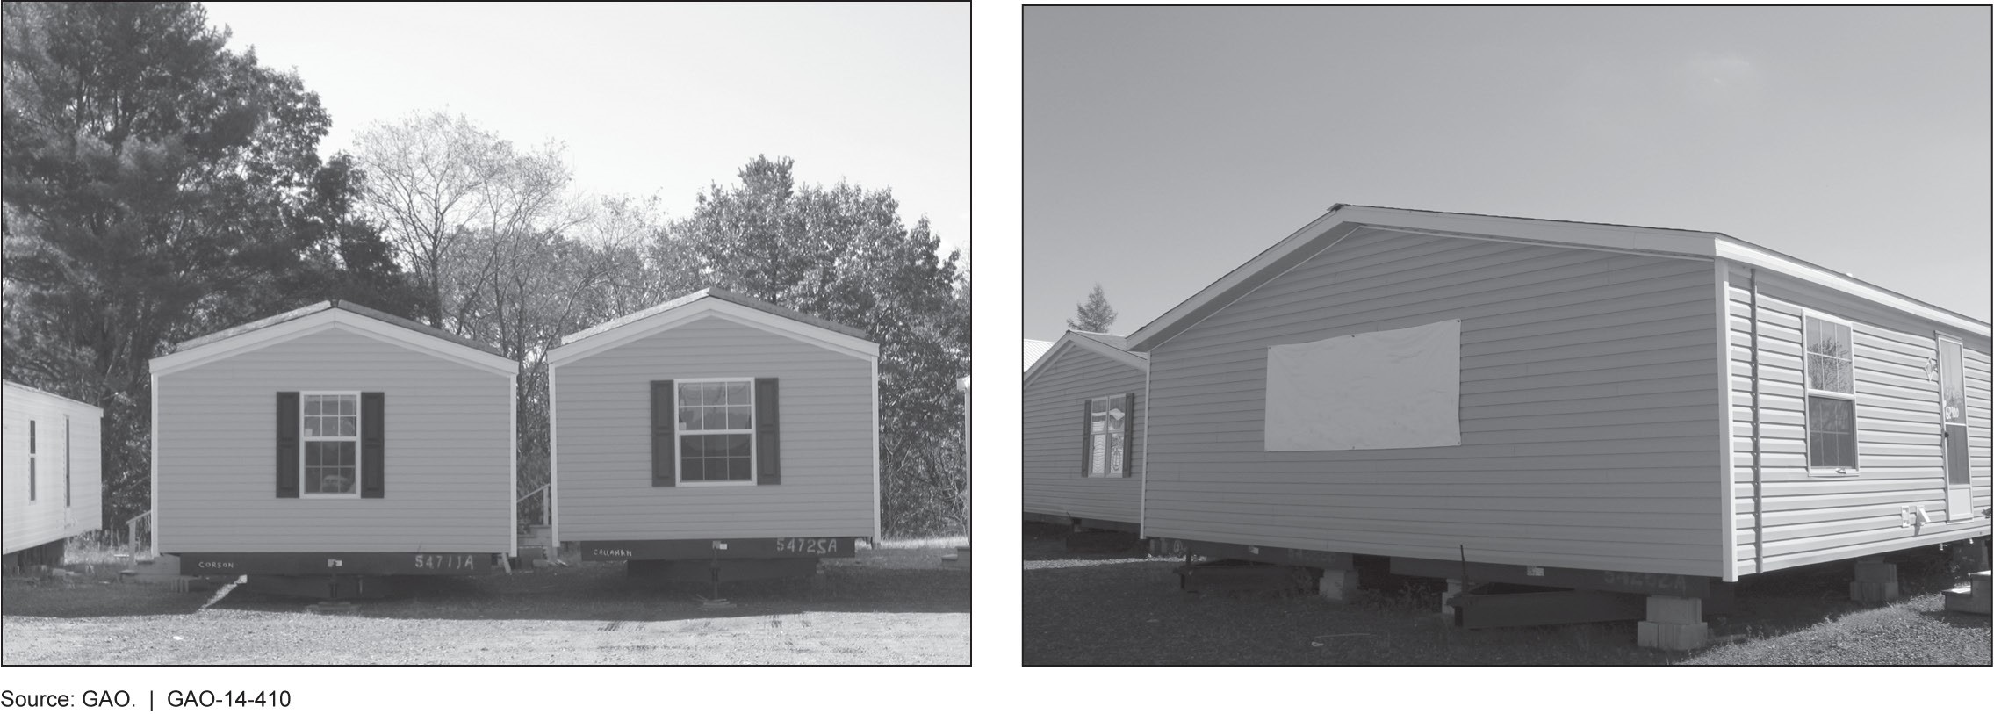

Figure 2: HUD Manufactured Home Placed on a Permanent Foundation with a Basement
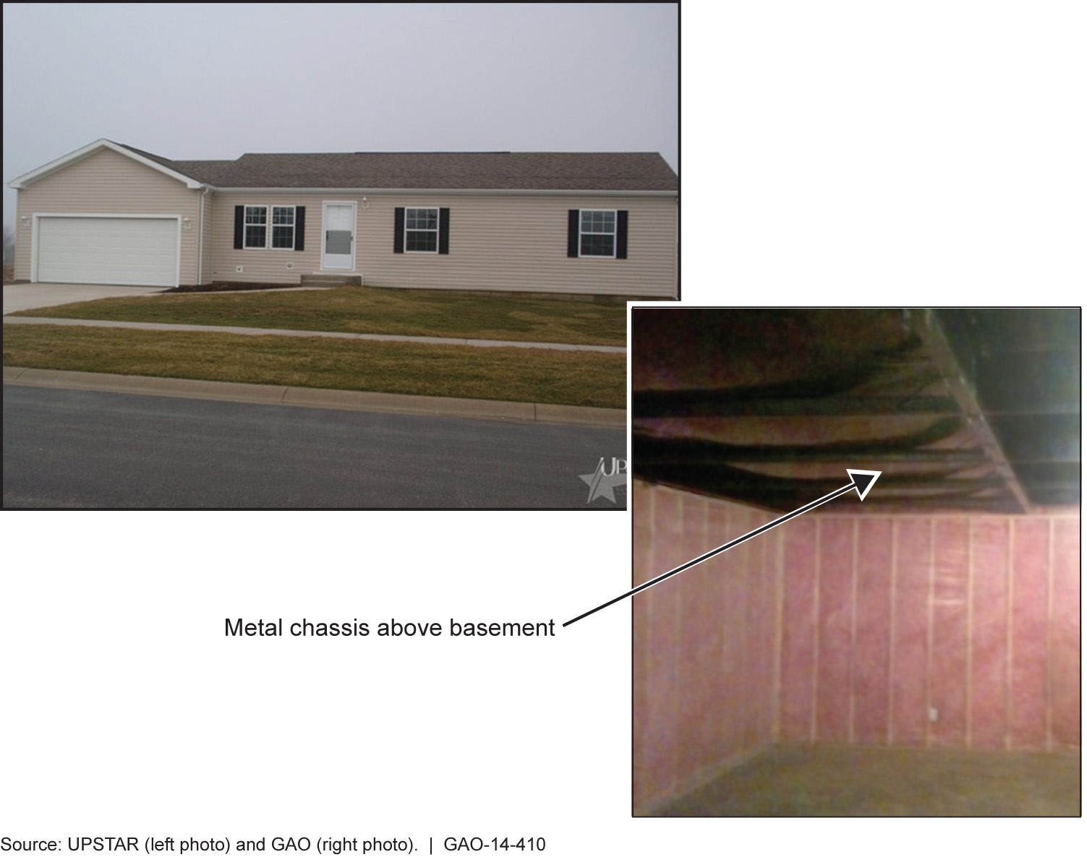

Manufactured homes also differ from modular homes, which are another type of prefabricated home and are often designed and constructed by the same manufacturers on the same production lines as manufactured homes. Like other site-built homes, modular homes are categorized as real property and are built to state and local building codes, most commonly the International Residential Code (IRC). Unlike manufactured homes that are towed to the sites on their own permanent chassis, modular home sections, or modules, are transported on truck beds and assembled on site. For the purposes of this report, we include modular homes under our definition of site-built homes.
Unlike site-built homes, which are titled as real property and usually financed through a mortgage, a manufactured home may be financed as either personal or real property. When a home buyer purchases a manufactured home without tying the purchase to land, the home is generally considered personal property, or chattel—that is, it is a movable, “personal” possession, much like an automobile. Manufactured homes are sometimes grouped together in communities where residents may either own or lease the home, but lease the land. However, according to Manufactured Homes Survey (MHS) data, in 2013 70.2 percent of manufactured homes were placed on leased or owned land outside of manufactured home communities. One lender we interviewed told us that homeowners in rural areas often placed manufactured homes on real property owned by a relative but did not want to place a lien on the land to purchase the manufactured home.
When a manufactured home is attached to the underlying land by a permanent foundation and the home and the land are treated as a single real estate title under state law, the home is considered real property. In such instances, the borrowers can obtain a conventional real estate loan or a government-guaranteed mortgage through traditional mortgage lenders. According to the MHS, 13.7 percent of manufactured homes that were placed in service in 2013 were titled as real estate, 78 percent were titled as personal property, and the remainder (8.3 percent) were not titled.

The Manufactured Housing Improvement Act of 2000 and General Duties of the HUD Office of Manufactured Housing Programs
The National Manufactured Housing Construction and Safety Standards
Act of 1974 was amended by the Manufactured Housing Improvement Act of 2000 (2000 Act) to create a balanced consensus process for establishing and revising manufactured home building standards. The 2000 Act created the Manufactured Housing Consensus Committee (MHCC), a Federal Advisory Committee charged with providing recommendations to the Secretary on the revision and interpretation of HUD Code and related procedural and enforcement regulations.
HUD’s Office of Manufactured Housing Programs is responsible for carrying out certain provisions of the 2000 Act. Under the law, the HUD Secretary is directed to establish appropriate federal manufactured home construction and safety standards as well as model standards for the installation of manufactured homes. The Office of Manufactured Housing Programs is tasked with regularly updating the standards based on careful analysis of MHCC’s recommendations, the manufactured housing industry, and consumers. The Office of Manufactured Housing Programs is also tasked with approving certain state agencies and private thirdparty entities that inspect manufactured housing plants to determine whether manufacturers are complying with the HUD Code. Each manufacturer contracts with two types of third-party entities, a Design Approval Primary Inspection Agency (DAPIA) and a Production Inspection Primary Inspection Agency (IPIA). Generally, DAPIAs review and approve all manufactured home designs, design changes, and quality assurance manuals. IPIAs are responsible for assuring that the manufacturing plant follows the quality assurance manual and inspecting each home at some stage of production in the plant. IPIAs also issue the HUD Certification Label that is attached to each section of the home upon completion (see fig. 3 below).

Figure 3: HUD Certification Label
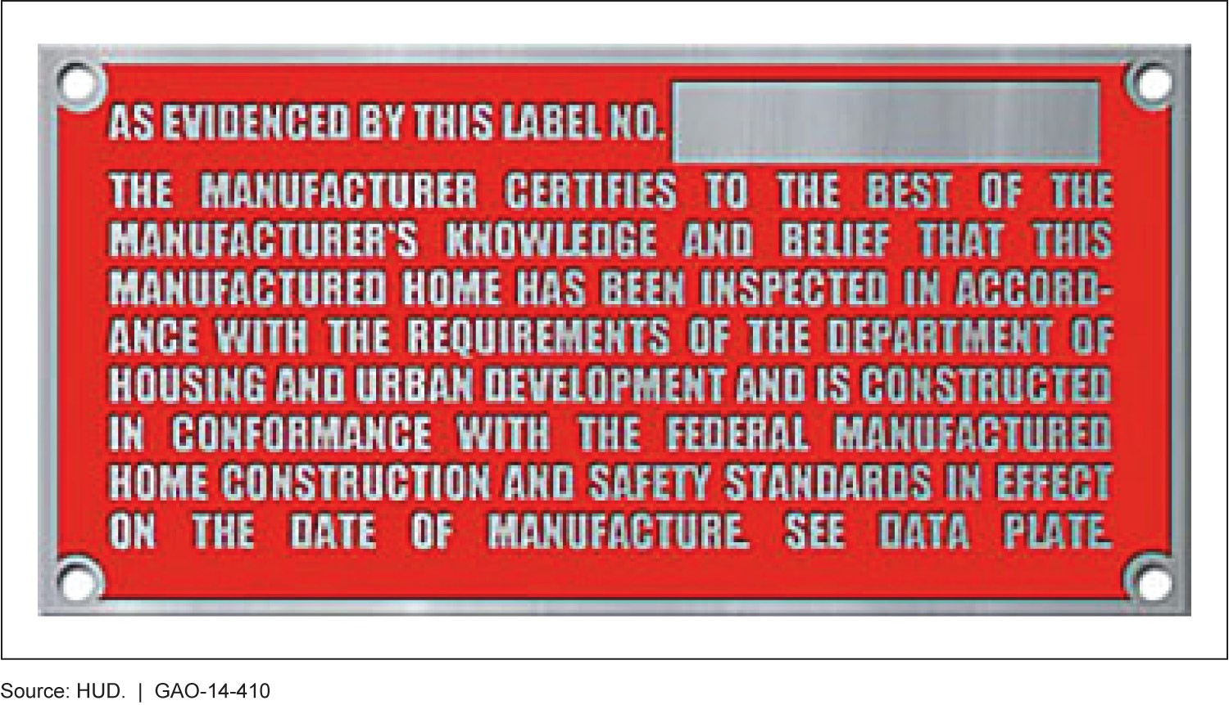

Federal Preemption The 1974 Act also established the preemptive status of the HUD Code, as it stipulated that if a home is built to the HUD Code, state and local building authorities may not apply their own codes that are applicable to the same element of performance.¹⁰ The 2000 Act stated that the federal preemptive authority was to be “broadly and liberally construed.” For instance, a state or local municipality cannot require that the distances between a HUD home’s air intake and exhaust vents be greater than the 3-foot minimum currently stipulated in the HUD Code. One particular entity that relies heavily on the preemptive status of the HUD Code is the Federal Emergency Management Agency (FEMA). FEMA is a large purchaser of manufactured homes, which are utilized as temporary housing units under its emergency management operations across different states.
To help ensure that all manufactured homes comply with the HUD Code, HUD has entered into cooperative agreements with 37 state governments that participate as state administrative agencies (SAA) to conduct periodic

10
42 U.S.C. 5403(d).
checks of plant records and to oversee the handling of consumer complaints. HUD’s staff is responsible for carrying out these same functions in the 13 states without SAAs and the District of Columbia (see fig. 4).

Figure 4: States with and without State Administrative Agencies, as of May 2014
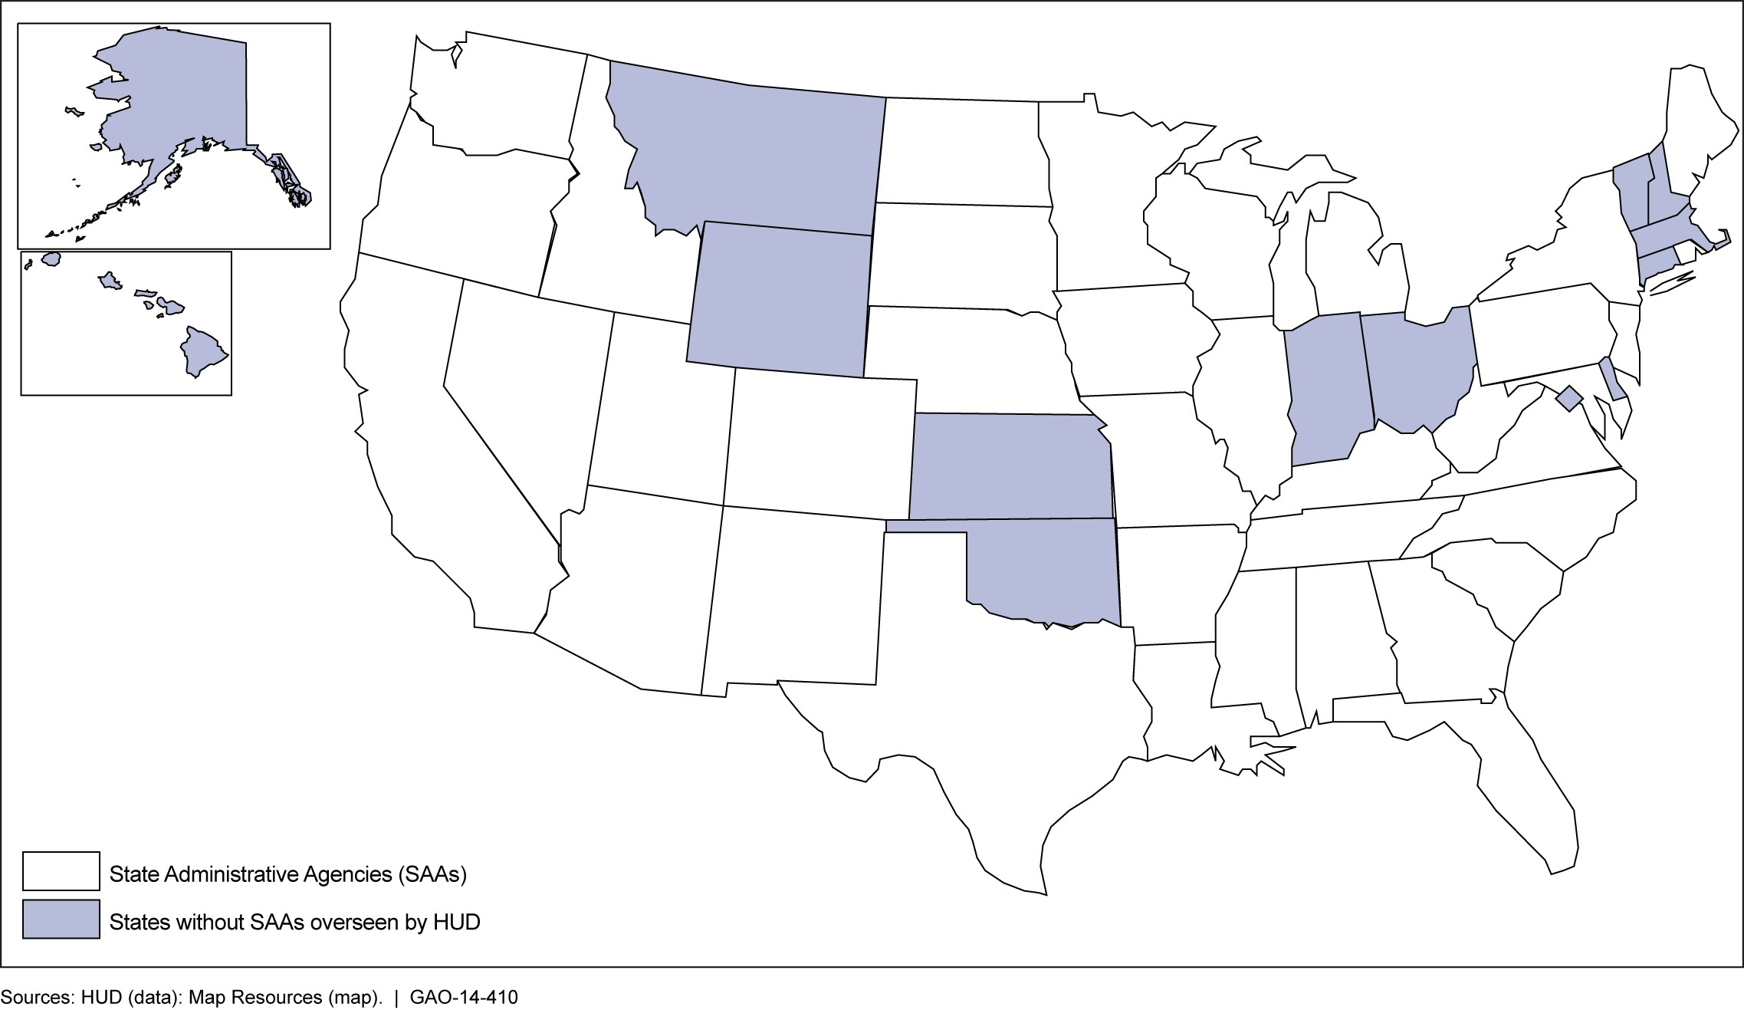

Despite Declining  Production,  Manufactured Homes  Remain an Affordable  Housing Alternative in  Some Regions | Annual shipment of new manufactured homes has declined substantially in recent years. According to the MHS, about 250,500 manufactured homes were shipped to retailers in the United States in 2000. In 2012 the number of manufactured homes shipped fell to 54,900 (see fig. 5). According to the MHS, manufactured homes shipments increased to about 60,000 in 2013.

Figure 5: Shipments of Manufactured Homes from 2000 to 2012
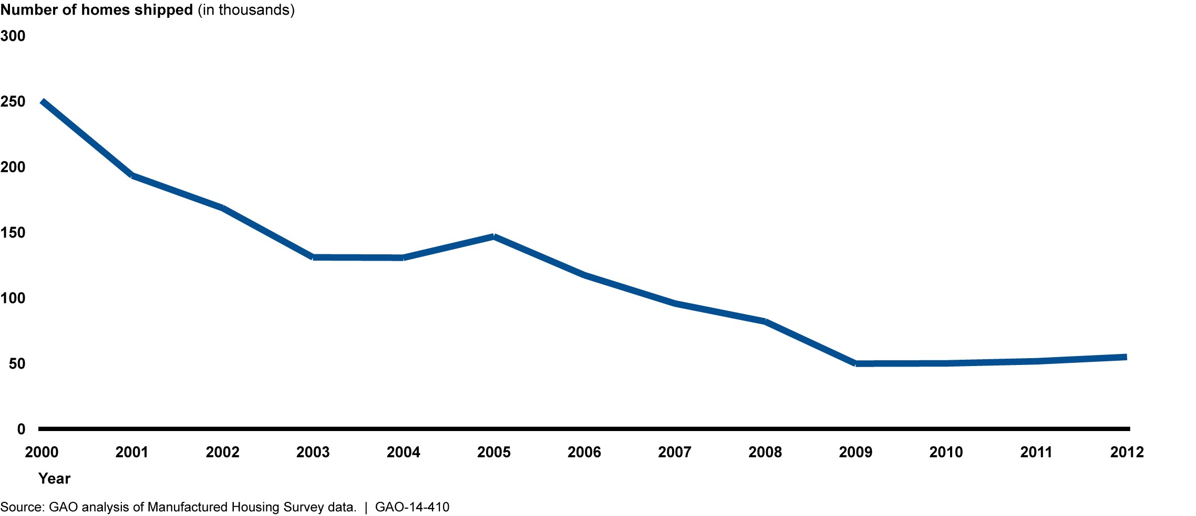

Despite the decline in new shipments in past years, in 2013 approximately 5.9 million HUD Code compliant manufactured homes were in use in the United States, accounting for 5.1 percent of total occupied housing units. However, the concentration of manufactured homes varies across regions. The southern United States, for instance, has the highest concentration, with manufactured homes making up approximately 8 percent of the region’s total occupied homes (see fig. 6). In addition, the majority of manufactured homes are located in nonmetropolitan areas, in part because of land constraints or barriers such as zoning laws in metropolitan areas. According to data from the 2011 American Housing Survey (AHS), over half of manufactured homes (52.4 percent) were located in non-metro areas in that year, compared to about
25 percent of single family homes and 11 percent of rented apartments.,

Figure 6: Manufactured Homes as a Percentage of All Occupied Housing Units, by Region
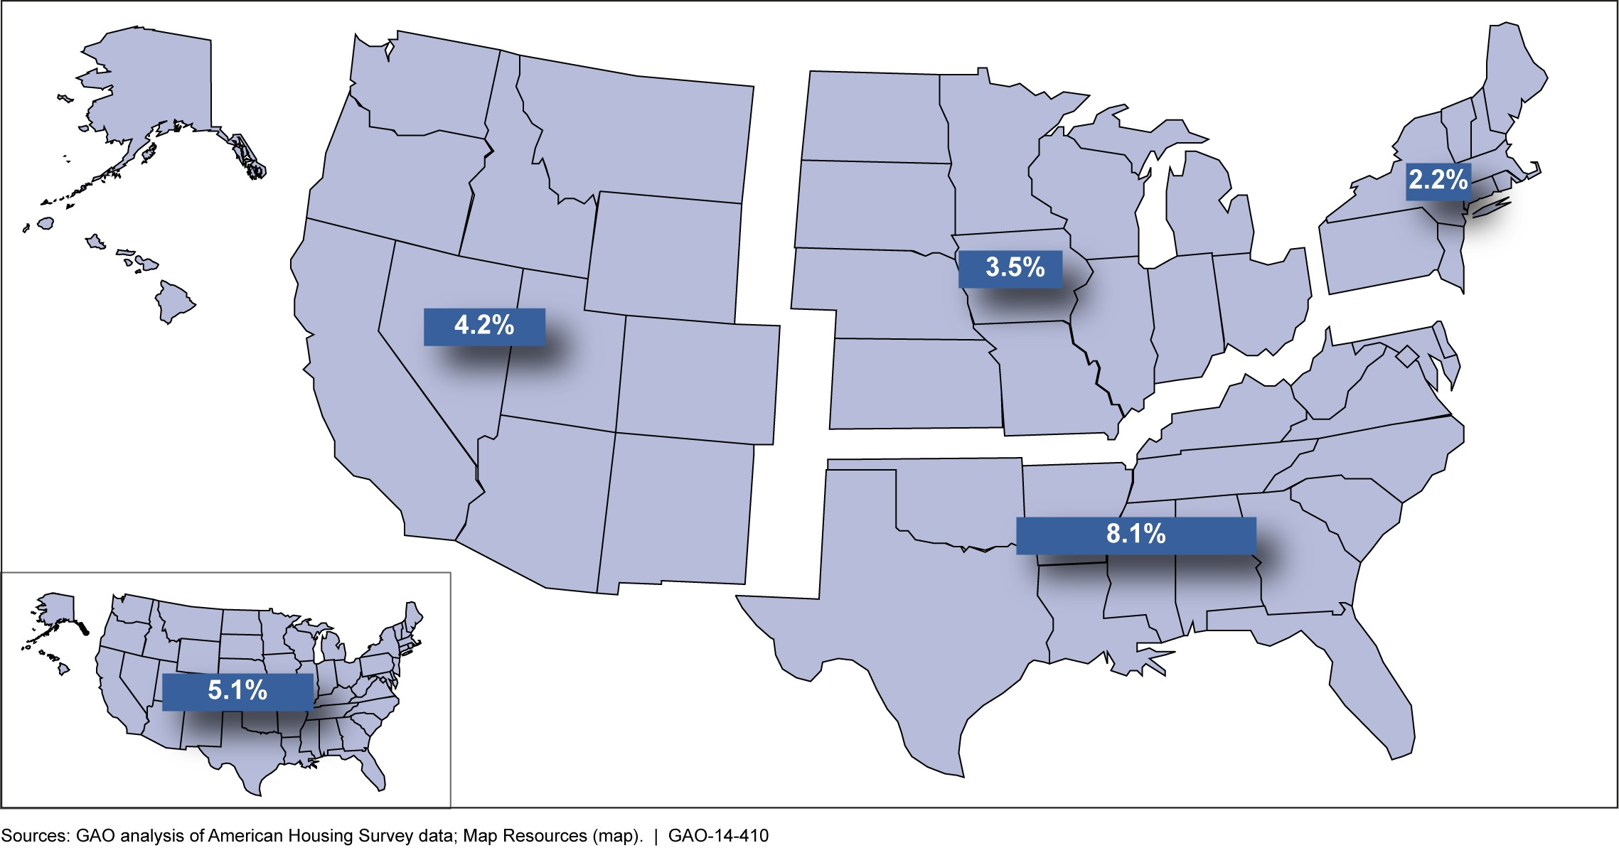

Note: These figures refer to occupied manufactured homes built after 1974.
As with other single family homes, manufactured homes tend to be occupied by their owners rather than rented to others. In 2011, about 81 percent of the manufactured homes built after 1975 in the U.S. were owner occupied, and 16 percent were rented for cash. In comparison, about 85 percent of all single family homes were owner occupied in 2011 (see fig. 7).

Figure 7: Ownership Characteristics of Occupied Manufactured Homes and Single Family Homes, 2011
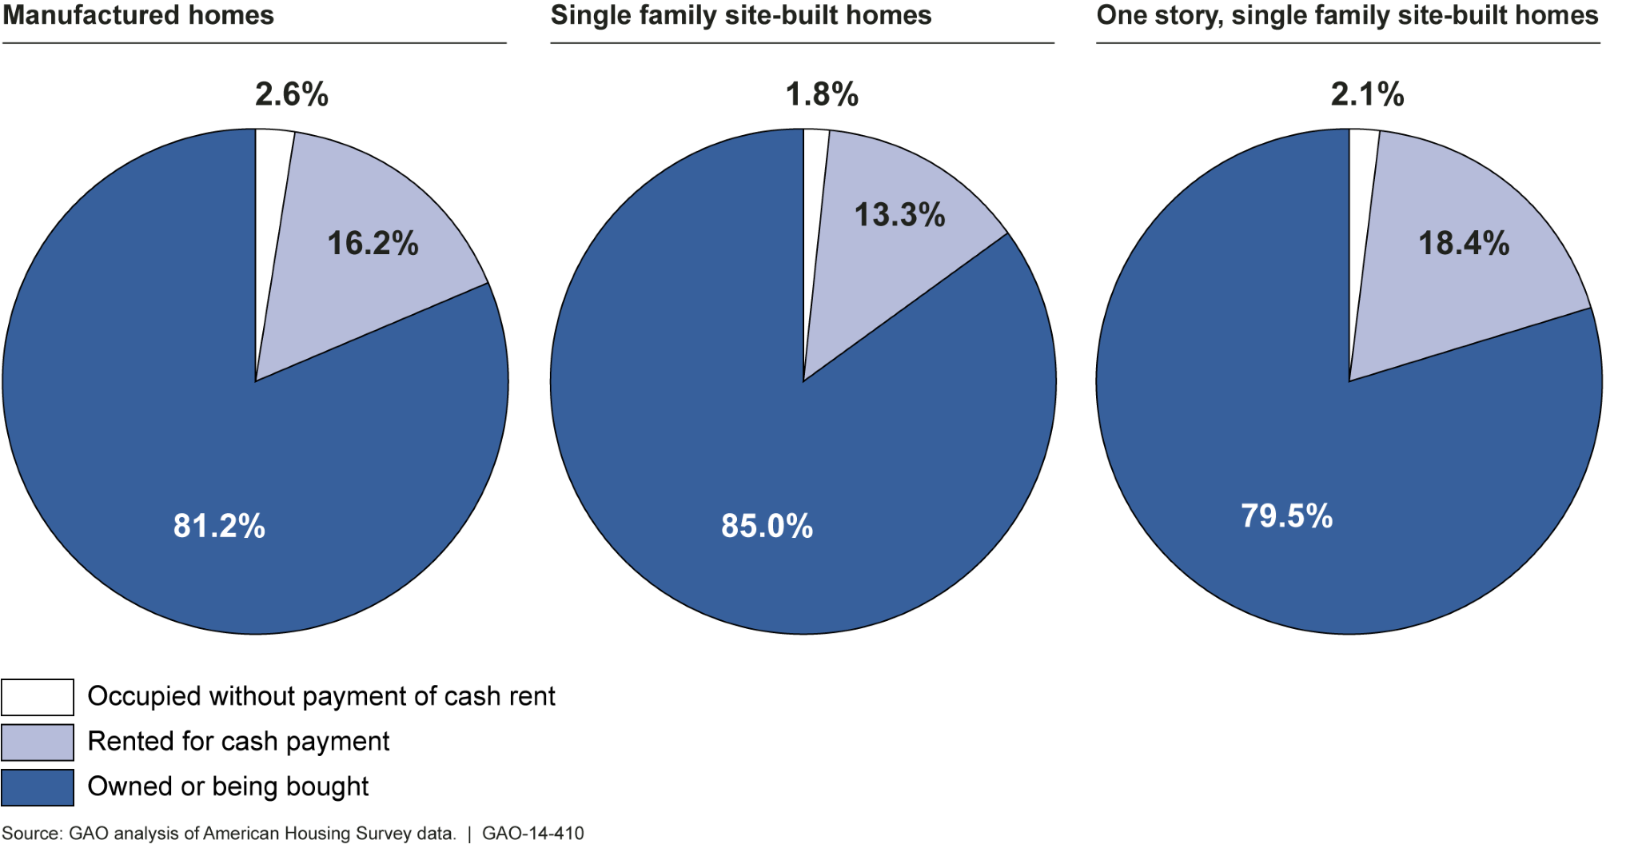
Note: The term “single family home” refers to single family detached homes, which are not attached to other homes like townhouses.

Our analysis also showed that owners of manufactured homes tended to have lower incomes than other homeowners. In 2011, about 75 percent of owners of manufactured homes had household incomes of less than $50,000, compared with about 77 percent of apartment renters, about 41 percent of owners of single family homes, and about 52 percent of owners of one story single family homes (see fig.8).

Figure 8: Income Characteristics of Owners of Occupied Manufactured and Single Family Site-Built Homes and Apartment Renters, 2011 (All Areas)
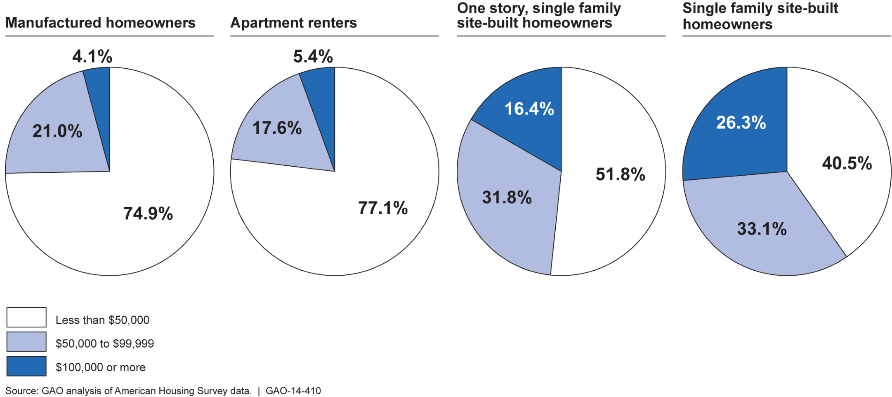

Our analysis also showed similar income characteristics for manufactured home owners located in non-metropolitan areas. In 2011, about 76 percent of owners of manufactured homes had household incomes of less than $50,000, as compared with about 90 percent of apartment renters, 51 percent of owners of single family homes, and about 62 percent of owners of one story single family homes (see fig. 9).

Figure 9: Income Characteristics of Owners of Occupied Manufactured and Single Family Site-Built Homes and Apartment Renters, 2011 (Non-metro Areas)
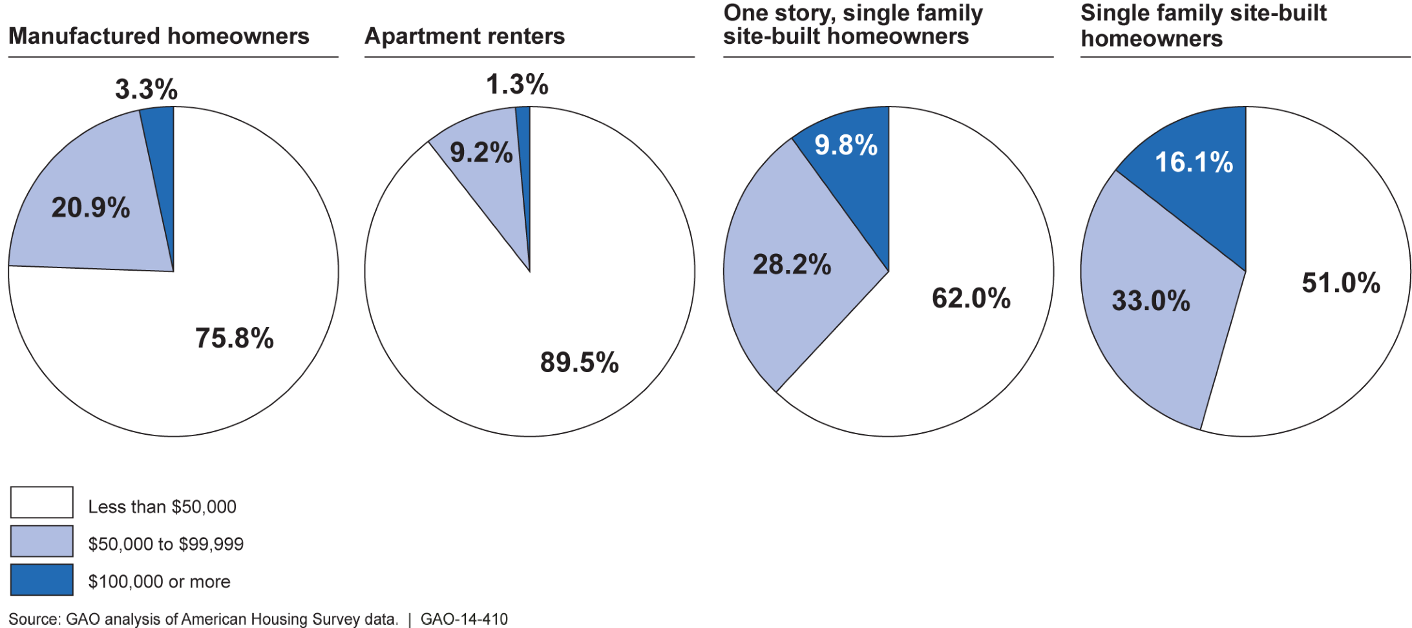

Our analysis of the 2012 MHS and 2011 AHS data also showed that manufactured homes were an affordable housing option in terms of their relatively low sales prices and monthly costs. In 2012, single-section manufactured homes were priced, on average, at $41,175 and multisection manufactured homes at $75,525. Manufacturers we interviewed said that these homes cost less to build than site-built homes, including modular homes, primarily because on-site construction and transportation costs for manufactured homes are less than those associated with modular homes and other site-built homes. Manufactured homes also typically had lower monthly costs, including loan payments, taxes, rent, utilities, and other fees, than site-built homes.
In 2011, around 16 percent of owners of manufactured homes paid $1,000 or more in monthly costs, compared with 55 percent of owners of single family site-built homes. Around 45 percent of manufactured home owners paid less than $500 in monthly costs, while 19 percent of owners of single family site-built homes paid less than $500 each month (see fig. 10). Owners of manufactured homes also had lower monthly costs than renters. According to the AHS data, the median monthly cost of owning a manufactured home in 2011 was approximately $550, while the median monthly costs for apartment renters that same year were $800.¹⁷

Figure 10: Monthly Housing Costs for Owners of Occupied Manufactured Homes,
Single Family Site-Built Homes and Apartment Renters 2011
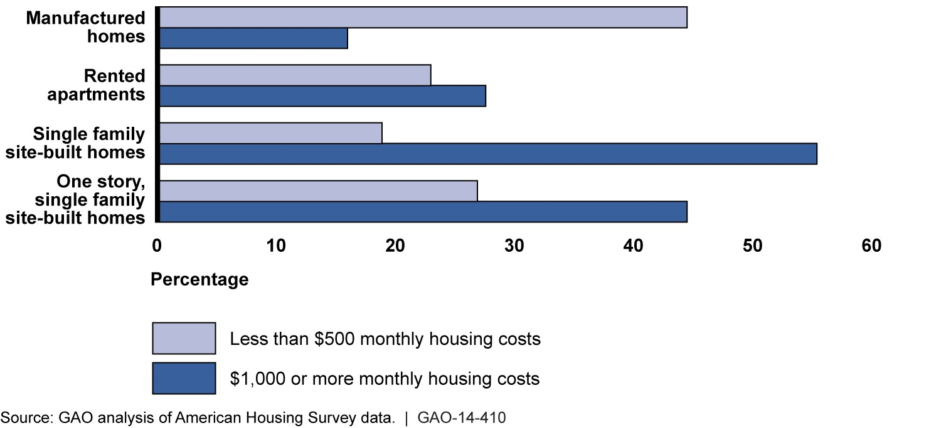

Although manufactured homes generally cost less to purchase than other homes and have lower monthly costs, owners of manufactured homes are more likely to have higher-priced financing than owners of site-built homes. According to 2012 HMDA data, manufactured home loans accounted for about 2.5 percent of all one-to-four family purchase loans. However, according to the HMDA data, they comprise 34 percent of all high-priced purchase loans. Moreover, 74 percent of conventional purchase loans for manufactured homes were identified as high-priced loans, compared with 24 percent of purchase loans supported by FHA, the U.S. Department of Agriculture (USDA), and the Department of Veterans Affairs (VA). Private lenders, such as national consumer finance companies, also provide financing for purchasing manufactured homes. Loans generally take the form of home-only or chattel loans
rather than real estate mortgages. According to some lenders we interviewed and one consumer organization, these loans typically have higher interest rates and shorter terms (15-20 years versus 30) than home mortgages.

HUD Has Not Fully
Achieved the
Manufactured
Housing Program’s
Key Purposes
HUD has encountered challenges in meeting key purposes of the 2000 Act, as seen by, among other things, delays and backlogs in its rulemaking process, limited assessment of financing alternatives, and incomplete documentation of enforcement-related activities. The purposes of the 2000 Act include (1) establishing a consensus-based process to update and interpret manufactured housing safety and construction standards and regulations for enforcing them; (2) facilitating the availability of affordable manufactured housing; and (3) ensuring uniform and effective enforcement of manufactured housing standards and protecting consumers. More specifically, the 2000 Act requires HUD to establish the MHCC to submit proposed standards within each 2-year period from the time its members are appointed. The MHCC must submit the standards in the form of a proposed rule, and include an economic analysis, for each proposal. The Act also requires HUD to publish each set of proposals within 30 days of submittal and respond to each set within a 1-year period. Further, it directs HUD to review the programs for FHA manufactured home loans, develop any changes that would promote the affordability of manufactured homes, and encourage the governmentsponsored enterprises (GSE) to develop and implement secondary market securitization programs for these loans. Finally, the Act requires that HUD ensure uniform and effective enforcement of the HUD Code.

HUD Has a Process for Updating the HUD Code, but Has Not Resolved Delays Related to the
Lack of Economic
Analyses
HUD has met the requirements for the initial establishment of both the MHCC and a process for updating the HUD Code. In 2001, HUD entered into a contract with an administering organization for the MHCC and continued to work with the contractor through June 2013, when the contract expired. HUD rebid the contract in July 2013 but as of the release of this draft to HUD in May 2014 had not awarded the contract to a new administering organization. This organization is a private-sector standard-setting body with specific experience in developing building codes. It is responsible for managing the MHCC—for example, recommending new members—and for administering the processes for developing new standards. As required by the Act, the MHCC consists of 21 members, who are all appointed volunteers. They represent three groups: producers and retailers, consumers, and general interest and public officers, including regulatory organizations. The administering organization first appointed members to the MHCC in August 2002. HUD last updated the roster of MHCC members in February 2013.
HUD has also put in place a process for updating the standards. First, MHCC reviews proposals submitted by its members, HUD, or the public. As required by the Act, if two-thirds of the MHCC members approve a proposal, the committee finalizes it and recommends it to HUD in the form of a proposed rule with an economic analysis. HUD is required to publish the proposed rule within 30 days of receiving the MHCC’s proposals. According to HUD officials, if the MHCC does not prepare a proposed rule with an economic analysis, HUD develops the proposed rule and the economic analysis. After this step, the proposal follows the typical rulemaking process, including an Office of Management and Budget (OMB) review, publication in the Federal Register, and a public comment period. After reviewing the public comments and possibly revising the recommendations, HUD adopts, modifies, or rejects the recommendation and publishes the decisions in a Final Rule (see fig. 11). HUD also

submits the rule to its congressional authorizing committees for 15 days before publication of the proposed rules.

Figure 11: HUD’s Process for Updating the Manufactured Housing Safety and Construction Standards (HUD Code)
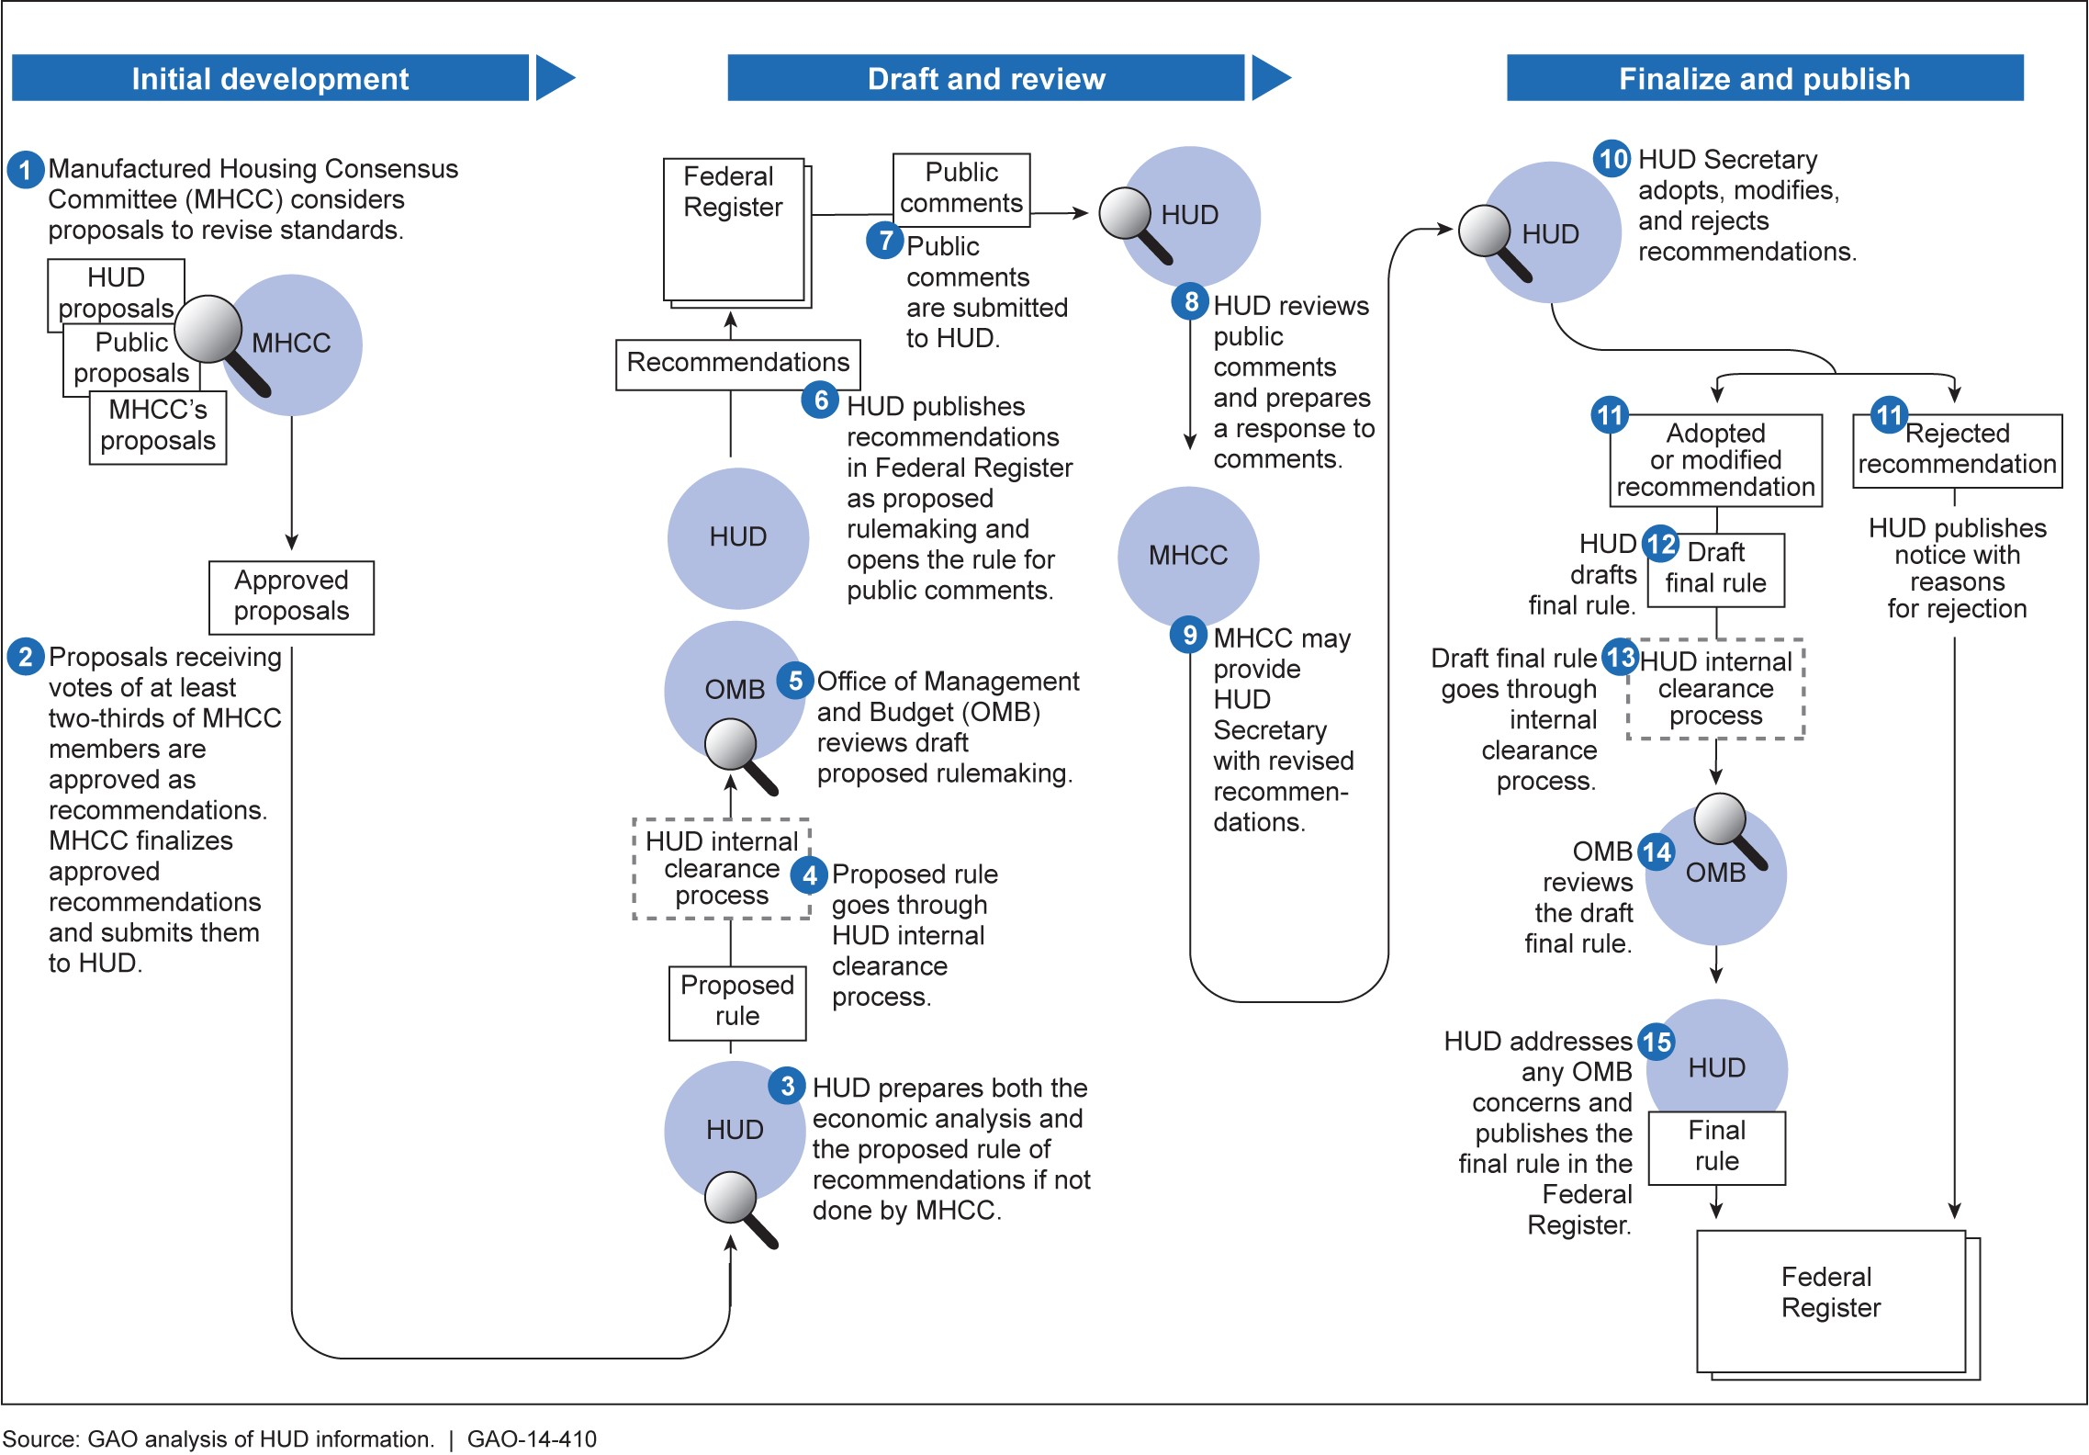
Note: The MHCC is an advisory committee established by Congress to provide recommendations to HUD on standards and monitoring of standards for manufactured housing.

For the most part, the MHCC has met the requirements for submitting proposed standards within each 2-year period. The MHCC last submitted recommendations for changes in the standards in January 2012 and January 2013, when it recommended approval of 9 proposals. However, HUD officials stated that because the former administering organization did not formally submit these last 9 proposed MHCC recommendations from January 2012 and January 2013, the agency will not begin to consider them until it receives them from a new administering organization. We found that from its inception in 2003 to January 2013, the committee submitted 174 recommendations.
As we have seen, the 2000 Act requires that not later than 12 months after receiving a MHCC recommendation to the HUD Code, HUD must either adopt and publish the recommendation as a final rule, reject the recommendation and publish the reasons for the rejection, or publish a modified version and provide for a comment period. However, we observed that HUD had not accepted, rejected, or modified any of the MHCC recommendations for updating the HUD Code within 1 year of their submission. According to HUD officials, the relevant procedural requirements and timelines for acting on MHCC’s recommendations were not triggered because the MHCC did not submit the recommendations in the form of proposed rules that included relevant economic analyses, as required by the 2000 Act. HUD officials said that the administering organization was responsible for providing technical support to the MHCC in developing proposed rules and economic analyses. For example, the contract for fiscal year 2013 required the administering organization to ensure the availability of subject-matter expertise necessary to support the satisfactory performance of the MHCC, including activities related to the federal rulemaking process. However, one official from the former administering organization told us that both it and the MHCC lacked the expertise and resources to draft proposed rules and conduct economic analyses. HUD and the administering organization have acknowledged that the MHCC does not have the expertise or resources to conduct economic analyses.²⁷ According to HUD officials, because the MHCC and the administering organization had not been able to develop proposed rules with adequate economic analyses, none of the submissions from the MHCC had been complete, and the 1-year statutory requirement for adopting, modifying, or rejecting MHCC proposals has never been triggered.
HUD officials also said that because of the lack of adequate proposed rules with economic analyses from the MHCC or its administrative agent, HUD staff have developed rules and done the analyses, delaying the rulemaking process. In fact, HUD’s revisions to the Code have taken substantially longer than the timeframes specified in the 2000 Act. HUD has updated the Code twice (in 2005 and 2013). According to HUD officials, in November 2005 (in its first update of the Code), HUD published a final rule in the Federal Register that contained 36 MHCC recommendations submitted in February 2003 and July 2004, most of which were adopted without any further modifications by it. The second update of the Code consisted of 49 recommendations also proposed by MHCC in 2003. While at least some of these recommendations were the subject of further discussions between HUD and MHCC, HUD did not publish a proposed rule in the Federal Register containing these recommendations until July 2010 and did not publish a final rule until December 2013. As of May 2014, HUD was still considering 35 recommendations that the MHCC submitted in 2009 and 2010. As stated earlier, according to HUD officials, because the administering organization did not formally submit an additional 9 recommendations in 2012 and 2013, HUD will not consider these recommendations until it receives them from a new administering organization (see fig. 12 for a depiction of the timelines for five examples of manufactured housing construction and safety standards for which HUD had completed final rules).

Figure 12: Selected MHCC Recommendations and HUD Updates to the HUD Code, 2003-2014
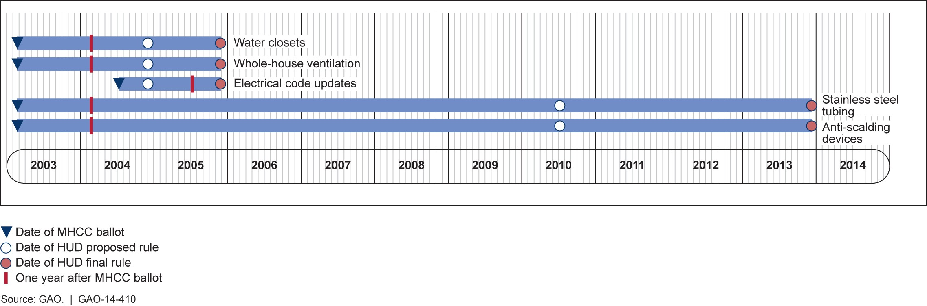
Note: For the purposes of this analysis, we considered a standard to be initiated on the date the MHCC approved it in a ballot from 2003 to 2013. We considered a standard to be finalized on the date it was published in the Federal Register as a final rule.

According to HUD officials, this additional workload posed by the tasks of developing proposed rules and economic analyses has further strained existing staff resources. Further, HUD officials voiced concerns over other administrative and legislative impediments to producing more timely updates to the HUD Code. These include the Act’s requirement that HUD publish a proposed rule within 30 days of receiving the MHCC’s
recommendations, the requirement for a 15 day pre-publication review by Congress, a 30-60 day public comment period, as well as allowing sufficient time for other administrative reviews, including review by OMB. HUD requested increased staffing for fiscal year 2005 to better meet the 1-year requirement for updating the standards, but staff levels have not increased. Also, the position of Administrator of the Office of
Manufactured Housing Programs remained vacant from 2010 until March 2014. Other than the earlier attempt at increasing staff levels, and facing ongoing challenges, HUD has no plan for ensuring more timely updates to the construction and safety standards. Standards for internal control emphasize the need for federal agencies to establish plans to help ensure goals and objectives can be met, including compliance with applicable laws and regulations.
As we previously found, the lack of updates to the HUD Code has delayed implementation of important safety devices, reducing the effectiveness of the standards and, over time, creating discrepancies between the HUD Code and other commonly accepted residential building standards, which are updated every 3 years. For example, the pending recommendations include requirements for carbon monoxide detectors, which are now incorporated in industry standards.
Safety concerns have led some states and localities to begin requiring certain safety features for homes in their jurisdictions. For instance, Pennsylvania state officials told us that at least one locality required that manufactured homes have anti-scalding devices in showers before the HUD Code included them in December 2013. The HUD Code did not address this area of performance and therefore, according to HUD, a jurisdiction could have imposed such a requirement without conflicting with the preemptive HUD Code. However, the costs to purchasers of a
manufactured home could be significant if the manufacturer had not already installed such a device. That is, a homeowner might be required by the locality to install such devices at a cost of hundreds of dollars. Further, according to officials from the State of Pennsylvania, this modification of the homes’ plumbing might void the manufacturers’ plumbing warranty. As mentioned earlier, the MHCC recommended antiscalding devices in February 2003 and the HUD Code will require these devices beginning in June 2014.
Several states, including California, Minnesota, and Maryland, require carbon monoxide detectors, which are not addressed by the HUD Code. The IRC and the American Society of Heating, Refrigerating, and Air-

HUD Has Done Little to
Assess How Federal Loan Programs Could Improve
the Affordability of
Manufactured Homes
Conditioning Engineers have required carbon monoxide detectors for all residential site-built and modular homes since 2009 and 2010, respectively. While the MHCC recommended in 2009 that this standard be required for all new manufactured homes, HUD has not yet adopted this proposal. According to HUD officials, as of May 2014 HUD is considering the proposal to require carbon monoxide detectors. Until HUD works its way through its backlog of proposals, purchasers of manufactured homes could face increased costs and, in some cases, potential safety hazards.

HUD offers two loan insurance programs that provide financing for manufactured homes, FHA Title I and Title II. Both programs are intended to insure lenders against losses in the event of a default. Homebuyers and homeowners may finance the purchase of or refinance their manufactured home, lot, or both through the FHA Title I program, which insures both chattel and mortgage loans. Manufactured homes titled as personal property are financed through chattel loans and would be eligible for Title I. Home buyers and homeowners may also finance the purchase or refinancing of their home through the Title II program, which insures mortgages for all types of single family homes, including manufactured homes that are classified as real estate. Manufactured homes titled as real estate and installed on a permanent foundation would be eligible for Title II.
Considering both its Title I and Title II loan programs, FHA plays a smaller role in the financing of manufactured homes than in the financing of other single family homes, according to HMDA data. Specifically, 2012 HMDA data, which include both chattel and real property manufactured housing loans, showed that FHA programs made up 17.5 percent of all loans for the purchase of manufactured homes, but 27 percent of loans for the purchase of one-to-four family homes. Although the Title I program is intended in part to serve the needs of the manufactured housing market, owners of manufactured homes use it less often than Title II. In 2012, FHA insured a total of 654 Title I manufactured home loans and 12,301
Title II manufactured home loans. According to data from the MHS, in

that same year nearly 41,000 newly placed manufactured homes were titled as personal property, while 8,000 newly placed manufactured homes were titled as real estate. FHA officials stated that they were not aware of specific barriers that consumers faced in obtaining Title I loans, but noted that two nationwide lenders participated in the program. Ginnie Mae securitizes FHA Title I manufactured home loans and works with these lenders. One Ginnie Mae official explained that although the agency had experienced losses from manufactured housing products in the past, the agency had conducted ongoing outreach with lenders to increase participation in the Ginnie Mae program. FHA arranged a meeting between Ginnie Mae officials and several manufactured housing stakeholders to discuss requirements for participating in the Ginnie Mae program. Industry representatives requested less stringent eligibility criteria for those wanting to issue Ginnie Mae-guaranteed securities backed by Title I loans. At present, Ginnie Mae requires that such issuers have a minimum net worth of $10,000,000. In contrast, issuers of securities backed by Title II mortgages must have a minimum net worth of $2,500,000. According to one HUD official, issuers of securities backed by Title I loans bore greater risk that necessitated the higher net worth requirement. A number of factors contribute to the increased risk, including higher losses because of greater frequency of default and lower insurance coverage. According to one Ginnie Mae official, Ginnie Mae had invited the industry to provide additional data to demonstrate the performance of their manufactured home loans, but had yet to receive a response. According to a Ginnie Mae official, it has continued to engage with lenders and industry representatives, but have so far received no data demonstrating the performance of these loans.
Further, Fannie Mae and Freddie Mac, which guarantee and purchase loans from mortgage lenders, play less of a role in providing liquidity to lenders of manufactured home loans than they do in providing liquidity to lenders of loans on other single family properties. HMDA data indicated that of conventional loans for manufactured homes, 7 percent were sold to Fannie Mae and Freddie Mac, compared to 41 percent of conventional loans for site-built homes. One lender of manufactured home loans cited certain underwriting constraints that limited their participation in Fannie Mae and Freddie Mac programs. For example, Fannie Mae requires an appraisal of the manufactured home with comparable local manufactured homes titled as real estate, a requirement that can be challenging, particularly in rural areas with relatively few homes and where many manufactured homes are titled as personal property. Fannie Mae and Freddie Mac do not purchase loans for manufactured homes titled as personal property.
Because of these constraints, most financing for manufactured homes, whether chattel or real property, is provided through private lenders. According to industry representatives and one lender, lenders often hold these loans in their portfolios and do not sell them on the secondary market. Some lenders we spoke with indicated that they declined to work with the FHA loan products because of the administrative burden. These lenders also stated that they believed Fannie Mae and Freddie Mac should buy chattel loans in addition to real estate loans. According to testimony given by the Manufactured Housing Institute during a House of Representatives field hearing on November 29, 2011, the lack of a viable secondary market for manufactured home loans has led to higher financing costs. The institute noted that the lack of liquidity in the manufactured housing market restricted buyers’ access to low-cost loans and that the available loans sometimes carried higher interest rates than loans for site-built homes. As stated previously, loans for manufactured homes are more likely to be higher priced than loans for site-built homes. Although some of these differences may be due to differences in credit strength, the generally higher interest rate associated with financing a manufactured home diminishes, in part, because of some of the affordability benefits that we discussed earlier.
Recognizing the impact that a lack of low-cost financing could have on the affordability of manufactured homes, Congress directed HUD in the
2000 Act to review the FHA programs for manufactured home loans.
The Act required that HUD develop any changes in, among other things, loan terms, amortization periods, regulations, and procedures that might promote the affordability of manufactured homes. However, HUD has not yet examined or researched the effectiveness of these loan programs because its research has focused on other priorities. HUD’s most recent study on manufactured housing focused on state and local regulatory barriers to placing manufactured homes in urban communities.⁴¹ Other research that PD&R has coordinated includes aspects of manufactured housing as they relate to energy efficiency and the environment. PD&R’s Research Roadmap for fiscal years 2014 through 2018 proposed researching the manufactured housing market and the effect of financing on manufactured housing demand. However, HUD did not select this proposal for its fiscal year 2015 Budget Request and, according to one HUD official, it was not among the highest priorities.
Such research could help HUD to understand the effectiveness of its programs in facilitating the affordability of manufactured homes. For example, data from the Rural Housing Services (RHS) program show that guaranteed loans on manufactured homes with permanent foundations perform worse than all RHS single family guaranteed loans. However, this analysis did not control for other factors that might explain these differences, such as borrower and property characteristics. FHA collects such data, which should permit a more rigorous analysis of loan performance. Further, FHA officials stated that they evaluate Title I manufactured housing loan performance and the Title I insurance fund to ensure that premiums are sufficient to cover program expenses, as required by the Housing Economic Recovery Act 2008 (HERA). However, FHA has not analyzed the performance of Title I and Title II manufactured housing loans to understand the different participation levels in the programs and lacks a plan for doing so. As noted earlier, standards for internal control emphasize the need for federal agencies to establish plans to help ensure goals and objectives can be met, including compliance with applicable laws and regulations. Such research could further HUD’s understanding of the relationship between loan performance and property type, providing information that it could potentially use to encourage lenders to participate in the federal program.
The Act also requires HUD to conduct research and make other efforts to encourage the enterprises and Ginnie Mae to actively develop and implement secondary market securitization programs for federally insured loans for manufactured homes, as well as those of other loan programs, in order to promote the availability of affordable manufactured homes. As we have seen, industry officials have cited the lack of a viable secondary market for manufactured housing loans as a factor in higher financing costs, especially for chattel loans. However, HUD was unable to identify any efforts, other than the discussions with Ginnie Mae, which it had undertaken to encourage the enterprise to do more to help securitize additional manufactured home loans. A Ginnie Mae official pointed to their prior experience in working with issuers of securities backed by manufactured home loans insured under the FHA Title I program. Specifically, he cited experience with lenders that were unable to fulfill their commitments, requiring Ginnie Mae to pick up servicing of their portfolios. The official also noted that lenders might not want to securitize their loans through Ginnie Mae because they had other sources of funding and wished to keep these loans in their portfolio. The official noted that one of the largest such lenders met the net worth requirement for Ginnie Mae and was an approved issuer of Ginnie Mae securities backed by Title I loans. Nonetheless, it is not clear that HUD has conducted research and other efforts to encourage the enterprises and Ginnie Mae to actively develop and implement secondary market securitization programs for FHA manufactured home loans or loans guaranteed by other federal programs.
Further, it remains uncertain that the enterprises would enter the market for securitizing loans on manufactured homes that are titled as personal property. Under HERA, which resulted in the enterprises being placed under conservatorship by the Federal Home Finance Administration (FHFA), Congress also directed the enterprises to serve specified underserved markets, including manufactured housing. HERA provided that in determining whether the enterprises had adequately served the manufactured housing market, FHFA could consider loans secured by both real and personal property. However, in 2010 FHFA published a proposed rule that would establish a method for evaluating and rating the Fannie Mae and Freddie Mac’s performance in underserved markets. The proposed rule also excluded loans for manufactured homes titled as personal property from consideration for securitization because, as FHFA stated, these loans would require substantial efforts by the Fannie Mae and Freddie Mac “to ensure safe and sound operations and sustainable homeownership for families.”

HUD Cannot Consistently Demonstrate That Issues from Inspection Monitoring  Activities and Complaints  Are Being Resolved | Another purpose of the 2000 Act is to help ensure uniform and effective enforcement of federal construction and safety standards for manufactured homes. To do this, HUD uses a monitoring contractor that reviews the activities of organizations that inspect manufactured home design and production activities. However, HUD could not demonstrate that it has consistently taken actions in response to the monitoring contractor’s “Recommendations for HUD Follow-Up.” These recommendations highlighted items that HUD should follow-up on based on the contractor’s review of IPIA and DAPIA inspections in manufacturing plants. For example, in some cases the HUD monitoring contractor noted that an IPIA was not performing inspections as required in certain plants and recommended that HUD take action to ensure that the appropriate corrective measures had been taken. HUD officials maintained that they did conduct follow up actions such as phone calls
and provided us with emails showing follow-up on some of the findings we inquired about, but did not provide documentation showing that the agency consistently acted on all the monitoring contractor’s findings or the outcome of follow-up actions taken. HUD officials also said that they had not been able to devote further attention to monitoring and following up on findings from the monitoring contractor because of resource issues and time limitations. Standards for federal internal controls suggest that, among other things, monitoring activities should assess the quality of performance over time and ensure that the findings of audits and other reviews are promptly resolved. Without consistent documentation of the outcome of these follow-up efforts, HUD has limited assurance that issues identified during the enforcement process are being resolved and that federal construction and safety standards for manufactured homes are uniformly and effectively applied.
HUD acknowledged that the monitoring contractor did not provide a deliverable from a recently completed monitoring contract period (July 2011 through July 2012). The missing item was a transition plan that would have documented activities tied to the monitoring contract in the event that HUD decided to assume the activities in the contract or hire a new contractor. The transition plan was intended to provide a plan for transferring all data and property associated with the contract to the government and/or a new contractor should HUD decide to assume the activities of the contract or transfer them to another contractor. Such information could aid HUD in exploring other options for conducting the work called for in the monitoring contract. Overall, such a condition raises questions and uncertainties about HUD’s oversight of its monitoring contract as well as whether the data that were not delivered in a transition plan represents significant noncompliance under the contract. Among other things, the Federal Acquisition Regulations (FAR) state that contracting offices are responsible for ensuring that nonconformances are identified, and establishing the significance of a nonconformance when considering the acceptability of supplies or services which do not meet contract requirements.^{, 48}
HUD also oversees a complaint process that is intended to help with the goal of ensuring uniform application of manufactured housing standards. In part, HUD relies upon the 37 state administrative agencies (SAA) that respond to consumer complaints and periodically review manufacturer facilities. However, HUD did little to assess the content of complaints. For example, HUD does not maintain a consolidated complaint log to evaluate in a systematic fashion the nature and resolution of complaints involving manufactured housing, or the entities involved. HUD’s website directs consumers to individual SAAs where they may file complaints. There are 13 states where no SAA exists, thus making HUD the primary focal point for complaints in those states. However, even for the complaints it does receive, HUD does not maintain a consolidated complaint log or record to identify their extent and nature. The complaint process has the potential to play an important role in quantifying the extent of complaints tied to homes built under the HUD Code, understanding the nature of complaints, and ensuring that the safety standards are followed. Standards for federal internal controls suggest that organizations, among other things, establish monitoring activities to assess the quality of performance over time, including identifying and correcting deficiencies within established time frames, which a comprehensive complaint system would help accomplish.⁴⁹
Looking ahead, we also noted that on-site construction activities pose new challenges for HUD’s inspection efforts on manufactured homes. HUD’s testing and inspection activities of manufactured homes are focused within the plant itself. However, some construction activities occur on-site. One of the most common building layouts to surface over time has been the construction of manufactured homes in two or more factory-built units, or sections (see fig. 13). For example, a manufactured home may consist of two complete sections that are joined together onsite to create a multi-section manufactured home. Consequently, other construction activities, such as the completion of siding and joining roofs, are occurring on-site, outside of the factory.

48
Since we sent a draft of this report to the agency for comment, HUD has accepted a transition plan from its monitoring contractor, which was the same entity that served as the monitoring contractor for the contract that ended July 2012.
49
GAO/AIMD-00-21.3.1.

Figure 13: Examples of Multi-section Manufactured Homes Joined On-site
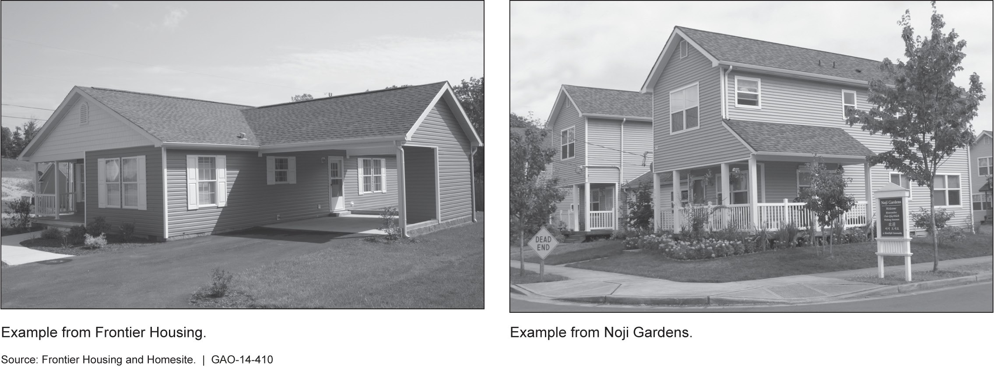

Other common construction methods—for example, adding a hinged roof to enhance the look of the home, or upgrading the energy efficiency of the home, also require construction and inspection activities on-site. However, HUD, through its monitoring contractor and IPIA entities, continues to focus almost exclusively on in-plant testing and inspections. For instance, HUD has developed in-plant inspection checklists for IPIA inspection entities to follow to help ensure compliance with the HUD Code while a unit is being constructed in the factory, but is still working on implementing more robust inspection processes for on-site construction activities.⁵² As homes are further customized, some variations, such as many hinged-roof designs, are categorized as alternative construction, requiring an on-site inspection, while other activities completed on-site are not currently subject to additional testing and inspection. HUD’s inspection checklists do not require testing of some key systems completed on-site or IPIA inspections of all units on-site. For instance, testing to validate the air-tightness of the home and performance of the ventilation system is required to receive an Energy Star certification during construction. However, the HUD Code cannot be used for such a certification because such testing is not currently required on-site once two sections of a multi-section HUD manufactured home are joined onsite. As on-site construction activities increase, HUD will continue to face challenges ensuring the inspection regime for manufactured homes keeps pace with and addresses such trends in construction methods.
Furthermore, as we have noted in previous work, HUD’s testing and inspection efforts to validate the quality of construction are also specified in the HUD Code. Consequently, any updates to specifications on testing methods for key components of the house require updates to the HUD Code itself. However, as discussed earlier, HUD has faced delays in updating the HUD Code. For instance, the Code specifies the test for the pressure that the roof is supposed to be able to withstand. However, as we found in our past report, some performance standards that are called for in the HUD Code, such as those pertaining to whole-house ventilation, are not currently being tested. Accordingly, we recommended that test methods be developed for the ventilation system, to help ensure proper indoor air quality, which requires an update to the HUD Code. HUD generally agreed with this recommendation and said that it has been referred to the MHCC for consideration.

Current Funds
Collected from HUD
Label Fees Are
Insufficient to Fund the Manufactured Housing Program
Label Fees Are the Primary Funding Source for the HUD Manufactured Housing Program

HUD is authorized to collect fees from builders of manufactured homes to offset the expenses it incurs in carrying out its responsibilities under the Manufactured Housing Program.⁵⁵ HUD currently assesses a $39 label certification fee per transportable manufactured housing unit produced by manufacturers. HUD set the level of the label certification fee in 2002 and has not increased it, although declining sales of manufactured homes mean that fee collections no longer cover the program’s annual costs. Under the 2000 Act, all HUD label certification fee collections from HUD transportable units are deposited into the Manufactured Housing Fees Trust Fund and are available for use to the extent provided in annual appropriations acts.⁵⁶ The 2000 Act also stipulated that the amount HUD charges for label fees may only be modified as specifically authorized in advance in an annual appropriations act and pursuant to a rulemaking.⁵⁷
In addition, the 2000 Act specifies the activities for which the Office of Manufactured Housing Programs may use the funds appropriated from the Manufactured Housing Fees Trust Fund.⁵⁸ HUD can use the label fees to cover contractual costs, carry out inspections, or monitor aspects of the program in the 13 states and the District of Columbia that do not have SAAs. HUD can also use them to pay the 37 SAAs that enforce the HUD Code and handle consumer complaint activities on HUD’s behalf to offset the costs they incur. Fees and appropriations from the general fund are held in the Manufactured Housing Fees Trust Fund. The Fund may

55
42 U.S.C. § 5419(a)
56
42 U.S.C. § 5419(e)
57
42 U.S.C. § 5419(d)
58
42 U.S.C. § 5419(a)
Since Fiscal Year 2009
Manufactured Housing
Program Obligations Have
Been Greater Than
Revenue from HUD Label
Fees
have reserves that are carried over from one fiscal year to the next, helping the Office of Manufactured Housing Programs make payments at the beginning of each fiscal year.

As the production and sale of manufactured homes generally declined after 2002, revenue collections from HUD certification label fees also fell, dropping to historically low levels in 2011. As we have seen, sales of transportable units fell from approximately 325,000 in fiscal year 2002 to around 90,000 in fiscal year 2013. This decline in sales, reflecting a decline in production, in turn, significantly reduced HUD’s revenue from label fees, which fell from around $12,000,000 in 2002 to less than
$3,000,000 by 2011 (see fig. 14).

Figure 14: HUD Label Revenues and HUD Units Sold from Fiscal Years 2002 to 2013
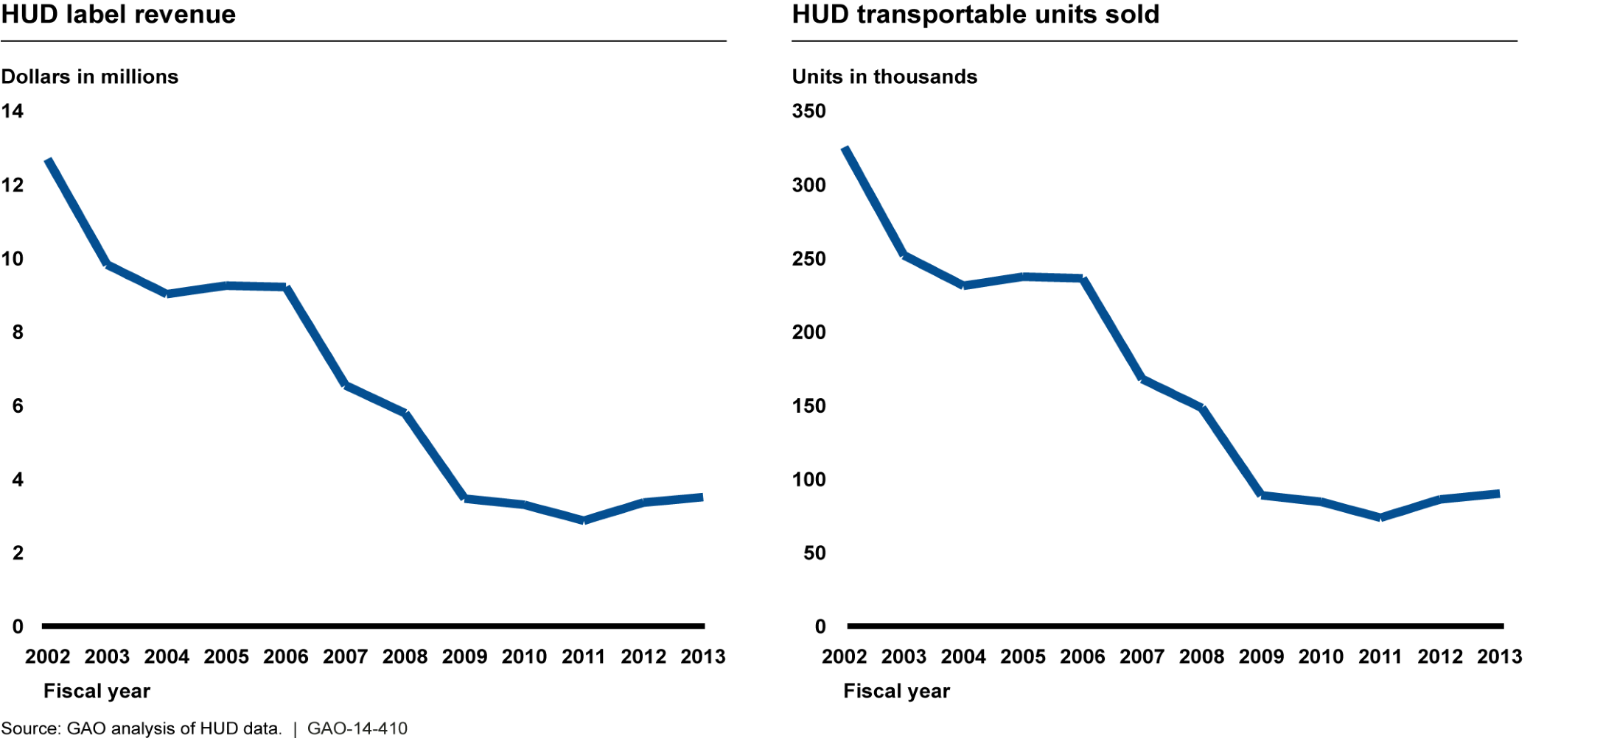
At the same time, obligations for the Manufactured Housing Program have increased. According to HUD, until 2009, the number of manufactured homes built and sold generated enough in label fee revenue to cover the costs of the HUD Manufactured Housing Program. Beginning in fiscal year 2009, however, the revenue that label fees generated was insufficient to cover the program’s obligations. According to data that HUD officials provided to us, the Manufactured Housing Program’s obligations were $6.62 million in 2009, when HUD generated $3.3 million in label fees. In each of the following years, HUD generated less revenue in label fees than it incurred in obligations. For the most recently completed fiscal year, fiscal year 2013, HUD had $10.1 million in obligations, while generating only $3.5 million in label fees. For fiscal year 2014, HUD estimates that program obligations will total roughly $10.0 million but the program will only collect $6.53 million in label fees.
According to officials, these obligations include expenses associated with office staff and program administration (including payments to SAAs), as well as costs related to MHCC activities—monitoring contractors, administration, and planning meetings. The officials said that payments to SAAs were a major programmatic cost and noted that the payments made to each SAA varied from year to year, depending on the activities the states undertook. For fiscal year 2014, HUD projected that the costs of annual SAA payments and the contract for monitoring inspection agencies of the Office of Manufactured Housing would total $7.3 million, or 73 percent of the program’s projected obligations. HUD officials noted that in recent years SAAs had been taking a more active role in HUD Code monitoring and enforcement and, as a result, HUD’s payments to them and the monitoring contractor had increased.
In order to meet its increasing budget obligations, the program has relied on congressional appropriations from the U.S. Department of Treasury’s general fund. From 2009 through 2013, the program took in approximately $16.1 million in label fees and had programmatic obligations of around $38.3 million. During this same period, the program received $22.2 million in congressional general fund appropriations to make up the gap between its program costs and label fee revenue. Furthermore, the program’s year-end carryover balances in recent years have been higher as a direct result of general fund appropriations that are available until expended (see fig. 15).

Figure 15: General Fund Appropriations and Carryover Balances for the HUD Office of Manufactured Housing Programs from Fiscal Years 2009 to 2013
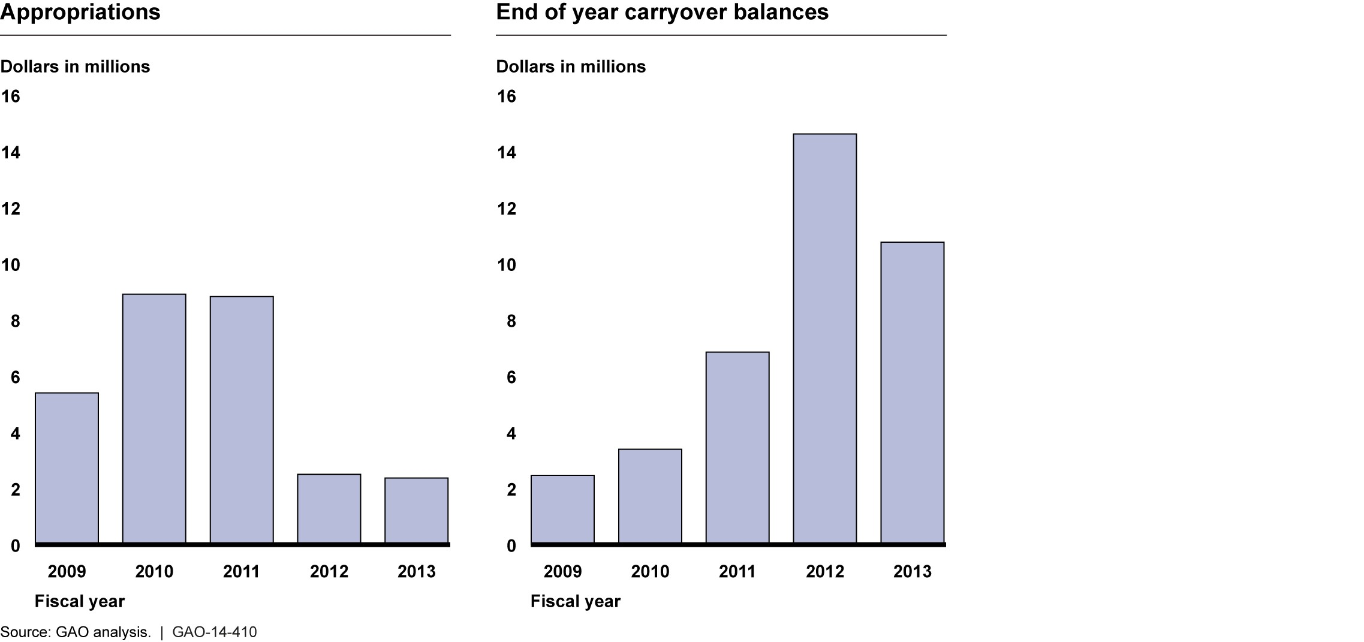

HUD User Fee Analysis In fiscal year 2014, HUD’s budget justification called for a total of $7.53
million in budget authority, including up to $6.53 million in estimated label fees and $1 million in general fund appropriations. In its fiscal year 2014 budget justification, the agency projected that the number of transportable units for which label fees are paid was not expected to significantly increase, and proposed an increase to the certification label fee of up to $100 in order to increase label fee revenue.
HUD’s budget justification for fiscal year 2015 also calls for an increase in label fees from $39 to $100. HUD’s Office of Manufactured Housing Programs currently projects a gradual increase in transportable unit sales through the end of fiscal year 2015 and estimates that fee collections in 2015 will be approximately $10 million dollars. The agency also stated in its 2015 congressional budget justification that its projected label fee revenue, combined with small amounts of unobligated balances from prior years, would be sufficient to fully fund the program’s operating requirements in 2015.
The HUD Office of Manufactured Housing Programs has stated its intent to raise label fees in previous HUD budget justifications dating back to fiscal 2009 and, as a result, had anticipated higher label fee collections in previous years. However, total user fee collections have fallen short of projections of the Office of Manufactured Housing Programs because it did not raise its label fees or seek other additional user fee income (see fig. 16).

Figure 16: Collected User Fees and Anticipated User Fees from Fiscal Years 2009 to 2013
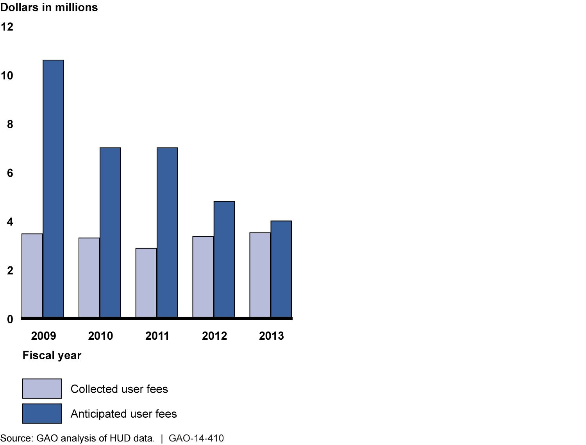
Note: HUD did not propose a label fee increase for 2013.

Despite its stated intent for several years to raise label fees, HUD did not take the necessary actions to implement these label fee increases. Standards for federal internal controls suggest that organizations, among other things, establish plans to achieve their objectives, including effective and efficient operations using the entity’s resources. Manufactured Housing Program officials stated that at the end of 2013 they had begun working with HUD’s Office of General Counsel on a proposed rule designed to raise label fees. At present, HUD officials stated their intent to have a final rule permitting this label fee increase ready to be implemented at the end of 2014. However, as of April 2014, the agency had not issued any notices of proposed rules regarding label fee increases.
Since fiscal year 2009, HUD has proposed increases to the label certification fee in all but one of its congressional budget justifications. The Chief Financial Officers (CFO) Act and OMB Circular A-25 provide for biennial fee reviews that include recommendations about adjustments to fees, as appropriate. While HUD Manufactured Housing Program officials told us that they have not conducted any such biennial reviews of their HUD label fees, program officials told us they have completed analysis of label fees in previous years. The label fee analysis that HUD officials provided to GAO was based on manufactured home production estimates, the amount of direct appropriations the program receives, the amount of carryover the program has from the previous year, and the anticipated program office activity and expense levels for the upcoming year.
We previously concluded that whether fee rates are set by the agency in regulation or by Congress in statute, agencies must substantively review and report on all cost-based fees regularly to better ensure decision makers have complete information about program costs and activities. Agencies should provide program information to agencies, stakeholders, and Congress. These reviews can improve transparency, help ensure that fees remain aligned with program costs and activities, increase awareness of the costs of the federal program, and therefore increase incentives to reduce costs where possible. We previously found that user fee design and review should address how the user fees will be linked to a program’s fixed and variable costs and whether or not user fees are set at a rate that enables the program to respond to spikes and surges in demand for the good or service upon which they are collected. Agencies should also seek to identify which factors drive fee revenue instability,

HUD Has Not Assessed
Other Authorized User
Fees or Program Goals
Related to the
Manufactured Housing
Fees Trust Fund
and whether or not a particular program has other sources of funding which may mitigate initial revenue shortfalls.
In order to identify and manage revenue instability, decision makers need regular information and analysis to understand potential vulnerabilities in the context of the specific fee design.The appropriate analysis can help an agency obtain a thorough understanding of factors such as cost drivers and elements that influence collections. Without regular comprehensive reviews, agencies and Congress may miss opportunities to make improvements to a fee’s design which, if left unaddressed, could contribute to inefficient use of government resources. For example, fee reviews could help ensure that fees are properly set to cover the total costs of those activities that are intended to be fully fee-funded, thus eliminating the need for direct appropriations for those activities.
Furthermore, not reviewing fees regularly can create costly challenges for user fee programs and agencies, such as larger fee increases, when fees are ultimately increased. Regular fee reviews can help ensure that Congress, stakeholders, and agencies have complete information about changing costs and whether a fee needs to be changed, help identify opportunities to revise fees in ways that enhance user funding of goods or services above and beyond what is normally available to the public, and can be a useful step towards examining whether the activities themselves are duplicative or overlapping.

Since fiscal year 2009, Congress has authorized the HUD Manufactured Housing Program to collect additional user fees in the form of installation fees and dispute resolution fees in states where HUD operates installation and dispute resolution programs. The 2000 Act required HUD to establish and implement a manufactured home installation program for states that chose not to operate their own installation programs. According to HUD, the federal installation program ensures the inspection of over 7,000 manufactured home installations annually, as well as the training and licensing of over 2,000 installers in the 19 states that do not

have such programs. Additionally, the 2000 Act requires HUD to establish and implement a manufactured home dispute resolution program for states that choose not to operate their own dispute resolution programs. The program provides for the timely resolution of disputes between manufacturers, retailers, and installers regarding responsibility for the repair of defects in manufactured homes. HUD maintains a dispute resolution program in the 23 states that have no such program.
Any dispute resolution and installation fees that HUD collects are to be deposited into the Manufactured Housing Fees Trust Fund and used to offset the costs of the Manufactured Housing Program. For fiscal years 2009 through 2012, the Office of Manufactured Housing Programs stated that it intended to collect a total of $11.2 million in fees from its dispute resolution and installation programs. However, HUD officials told us that the agency had not collected any of these fees, citing reasons such as the insufficient resources to implement such fees and the considerable administrative and logistical burden the agency would face. Under the authority granted in section 620 of the 2000 Act allows the Office of Manufactured Housing Programs to use HUD label fees to help pay for other aspects of the program, such as the dispute resolution and installation programs. However, as we have seen, because HUD has not increased label fees it has not generated sufficient fee revenue to meet the program’s costs. Despite this shortfall in fee revenue, HUD has not assessed how it might put in place a program for assessing and collecting installation and dispute resolution fees, nor has it assessed the costs and benefits that such a program might realize.
HUD officials also stated that they have yet to develop any specific program goals that would help in establishing a minimum or maximum amount of reserve funding for the Manufactured Housing Fees Trust Fund or the appropriate levels of program carryover balances for the Manufactured Housing Program. Officials stated that the program’s carryover balances vary from year to year; are based on label fees collected, general fund appropriations, and program obligations; and are capped each year by the budgetary authority granted to the Office of Manufactured Housing Programs in each year’s congressional appropriations act. HUD officials stated that each fiscal year’s carryover balance is established by the remaining amount of funding available once all program obligations had been paid, and consequently they saw little need to examine the costs or benefits of establishing longer or shorter goals for the Manufactured Housing Fees Trust Fund. Regardless of the authority under which a user fee reserve is created, setting clear goals for the reserve and clarifying how those reserves will be used helps ensure accountability and transparency both to Congress and users of fee-based programs. Agencies may wish to use a reserve to help ensure long-term financial stability, to position the agency to respond to varying economic conditions, to smooth expected fluctuations in costs or collections, or to build capital for necessary infrastructure improvements or mitigate unforeseen and unavoidable revenue shortfall. To further ensure accountability and adherence to any reserve fund goals, establishing minimum and maximum reserve levels, justified by program data and risk management considerations, may be advisable.

Conclusions Longstanding unresolved issues in implementing reforms to the HUD Manufactured Housing Program limit the potential for achieving key
purposes specified in the 2000 Act. Although the 2000 Act mandates that HUD act on proposed changes to the HUD Code within a 1-year period of the proposal being approved by the MHCC, this requirement has not been effective in accelerating the rulemaking process. HUD has not considered any of the proposals made by the MHCC to be subject to the 1-year deadline because the MHCC has not submitted recommendations in the form of proposed rules with adequate economic analyses, as required by the Act. Because the MHCC and the previous administering organization lacked the expertise to develop recommendations in the proper form, HUD’s staff has developed the proposed rules and conducted the economic analyses with limited staff resources. Despite these longstanding shortcomings, known resource limitations, and other administrative and legal impediments it faces, HUD has not identified how it might ensure more timely updates of the standards in achieving the purposes of the Act. As a result, it took over 10 years after receipt of a proposal from the MHCC for HUD to make some of the recent updates to the HUD Code. In contrast, building codes for use in site-built (including modular) homes are updated on a recurring basis every 3 years raising questions about HUD’s effectiveness in establishing meaningful and timely standards for manufactured housing. Ultimately, delays in updating the standards can result in families seeking an affordable housing option bearing additional costs when they must retrofit their homes to meet local and state standards that have outpaced the scope of the HUD Code, or being denied the benefit of safety and other standards that the consensus committee has recommended.
Although the higher cost of financing manufactured homes can limit their potential affordability, HUD has done little to implement the Act’s requirements for reviewing FHA programs for providing manufactured home loans and developing any changes that might further promote the affordability of manufactured homes, or for conducting research and other efforts to determine the potential for the enterprises and Ginnie Mae to actively develop and implement better secondary market securitization programs for manufactured home loans. Although HUD PD&R proposed a study on the financing of manufactured homes for its 2014 to 2018 Research Roadmap, HUD selected other research projects over this proposal and does not yet plan to conduct this study. Without analysis and research into the contribution financing might make toward the affordability of manufactured housing, HUD has little assurance that its loan programs and securitization programs of Ginnie Mae and the enterprises are appropriately promoting the availability of affordable manufactured homes.
HUD’s efforts to ensure compliance with the HUD Code rely on actions of others, including the monitoring contractor that reviews the activities of inspectors of manufacturers. However, we found that HUD lacked consistent documentation of actions it had taken in response to significant audit findings of the monitoring contractor. Further, HUD has no mechanism to catalogue complaints received by HUD and the SAAs. Without such documentation and transparency, HUD cannot determine the nature and content of complaints and whether any patterns might suggest further analysis or action. Ultimately, these weaknesses limit the potential for the enforcement process to ensure that federal safety and construction standards for manufactured homes are having their intended effect. Given its limited resources, HUD will likely face continued challenges in ensuring its standards are followed and needs to make the most efficient use of the resources it does have to enforce those standards.
In recent years, the HUD Manufactured Housing Program has relied on general fund appropriations to bridge the gap between its declining label fee revenue and its higher programmatic obligations. The current fee structure, which is based on per unit fees charged for labels indicating that units have been built in accordance with the HUD Code, is at its present amount not sufficient to fully fund the program. However, HUD had not put in place the increased label fees that it had proposed in 5 of the last 6 fiscal years. Nor has HUD taken steps to rigorously assess
the feasibility of establishing inspection and dispute resolution fees that Congress has authorized. The 1990 CFO Act and OMB guidance provide for biennial fee reviews that include recommendations about adjustments to the fees, as appropriate. A rigorous analysis of user fees can help an agency obtain a thorough understanding of factors such as cost drivers and elements that influence collections. HUD cited a number of reasons for not increasing label fees or considering other fees, including political pressure, the presence of large carryover balances that grew after receiving general fund appropriations, and challenges in implementing new user fees. Given manufactured home production levels in recent years and the constrained resource environment that the federal government faces, it is important for HUD’s Office of Manufactured Housing Programs to consider all revenue streams at its disposal including higher label fees and the potential for others fees already authorized by Congress. Further, delaying increases in user fees has the potential to require even higher fee increases when they are ultimately made—increasing any potential disruption to the manufactured housing market.
Finally, the HUD Office of Manufactured Housing Programs has not established any programmatic goals for the Manufactured Housing Fees Trust Fund, or established recommended minimum and maximum reserve levels. Due to a lack of analysis, HUD may be unaware of the optimum levels of trust fund reserves or yearly carryover balances needed to maximize the Manufactured Housing Program’s operational efficiency. GAO best practices state that unobligated balances in fee programs may represent a reserve intended to manage the effects of revenue instability. Setting clear goals for a program’s user fee reserves and clarifying how those reserves will be used can help ensure both accountability and transparency to Congress and users of fee-based programs. To further ensure accountability and adherence to any reserve fund goals, establishing minimum and maximum reserve levels, justified by program data and risk management considerations, may also be advisable. However if agencies and Congress are not deliberate in their design of a reserve fund to effectively manage an agency’s user fee program, any unobligated funds built up may be rendered ineffective as a reserve fund. In an era of limited resources, these steps will help HUD provide the most reliable information to Congress as it considers program funding and the sufficiency of fund reserves.

Recommendations for To better ensure the viability and safety of manufactured housing produced in accordance with the HUD Code, the Secretary of the
Executive Action Department of Housing and Urban Development should take the following
three actions:
- Develop and implement a plan for updating construction and safety standards for manufactured homes on a timely, recurring basis to include:
- addressing unresolved issues related to defining and developing sufficient economic analyses tied to proposed changes to the construction and safety standards; and
- ensuring sufficient resources and capacity within HUD and the MHCC and its administering organization; or if such a plan cannot be devised and implemented, identify and report to Congress on alternative methods of ensuring the quality, durability, safety, and affordability of manufactured homes, including the possibility of relying more extensively on existing industry standards.
- Develop a plan to assess how FHA financing might further promote the affordability of manufactured homes and identify the potential for better securitization of manufactured housing financing.

- Strengthen the oversight of inspections and enforcement-related activities by
- consistently documenting actions taken to resolve recommendations from completed audits and the outcome of such actions,
- completing a Transition Plan for the monitoring contractor activity, and
- exploring the feasibility of developing a cost-effective systematic process for collecting and evaluating information on the content of complaints.
To better ensure that Congress, stakeholders, and agencies have complete information about changing costs and whether a fee needs to be changed, HUD should:
- Complete the necessary rulemaking changes to allow the Office of Manufactured Housing Programs to adjust its label fees from the $39 per label toward levels up to the congressionally authorized level that better reflect the current levels of manufactured home production, while considering the impact that such fees may have on the industry; put in place a process for regular fee reviews to determine whether the fees currently being charged will allow the program to respond to spikes and surges in label fee revenue and to identify any factors that may drive label fee revenue instability; and identify any additional sources of funding that may mitigate initial revenue shortfalls and the program’s fixed and variable costs.

- Assess the feasibility, including an analysis of the benefits and costs, of putting in place user fees for its dispute resolution and installation programs.

- Establish the goals for use of reserves of the Manufactured Housing Fees Trust Fund, and the minimum and maximum thresholds for the reserves appropriate for meeting these goals.

Agency Comments and Our Evaluation | We provided a draft of this report to HUD for review and comment. HUD provided written comments that are discussed below and presented in Appendix I. HUD agreed with two recommendations, partially agreed with two recommendations, and stated its intent to consider the remaining two recommendations. HUD also described actions it planned to take or had taken in response after receiving the draft report. We reiterate the importance of HUD addressing fundamental program weaknesses and that it efficiently use the resources it has and take advantage of all potential sources of revenue. We therefore continue to recommend that HUD act on the report’s recommendations. HUD also provided technical comments that were incorporated as appropriate.
HUD agreed with our first recommendation to develop a plan to accelerate future updating of the construction and safety standards on a timely, recurring basis. Specifically, this plan would address, among other things, unresolved issues related to the economic analyses that must accompany proposed rules and ensuring that MHCC has sufficient resources to perform its duties. However, HUD said that implementing such a plan would be contingent upon its appropriations levels. As we stated in our report, HUD will likely face continued financial challenges in ensuring that its standards are followed and will need to make the most efficient use of available resources to enforce them. However, as stated in the report, we found that the lack of updates to the HUD Code had delayed implementation of important safety devices, reducing the effectiveness of the standards and, over time, creating discrepancies between the HUD Code and other commonly accepted residential building standards, which are updated every 3 years. For example, several states require carbon monoxide detectors, which are not addressed by the HUD Code. The IRC and the American Society of Heating, Refrigerating, and Air-Conditioning Engineers have required carbon monoxide detectors for all residential site-built and modular homes since 2009 and 2010, respectively. Until HUD addresses the backlog of MHCC proposals, purchasers of manufactured homes could face increased costs due to a need to retrofit these homes and, in some cases, potential safety hazards. We also recommended that if HUD cannot devise and implement a plan for more timely HUD Code updates and improve its workforce planning efforts and budget submissions, it should identify and report to Congress alternative methods of ensuring the quality, durability, safety, and affordability of manufactured homes, such as relying more extensively on existing industry standards.
HUD partially agreed with our second recommendation. HUD stated that Ginnie Mae agreed to develop a plan to identify the potential for better securitization of manufactured housing financing and that FHA would coordinate with Ginnie Mae as needed. However, HUD did not agree to develop a plan to assess how FHA financing might further promote the affordability of manufactured homes. HUD responded that FHA continuously monitors its programs to ensure that affordable credit is available. HUD added that FHA manufactured home policies and information on FHA Title I loans is to be included in HUD’s Single Family Policy Handbook, which is under development. Consolidating such program guidance may help lenders better understand FHA programs, but there is more that FHA could do to systematically assess how FHA financing might further promote the affordability of manufactured homes. The first step is to plan for such an assessment, as we recommend. As we state in our report, owners of manufactured homes use the Title I program, which was intended in part to serve the needs of the manufactured housing market, less often than Title II. FHA officials were not aware of barriers that might have precluded homeowners from applying for Title I loans. Recognizing the impact that a lack of low-cost financing could have on the affordability of manufactured homes, Congress directed HUD to review the FHA loan programs. However, as noted in the report, HUD has not taken action to fully address this requirement. As such, we recommended that HUD first develop a plan to formulate its actions to help ensure that the goals and objectives of these loan programs can be met. Without an analysis of and research into the contribution financing might make toward the affordability of manufactured housing, HUD has little assurance that its loan programs are appropriately promoting the availability of affordable manufactured homes. Thus, we continue to believe HUD should take action to fully implement this recommendation.
HUD agreed with our third recommendation to strengthen oversight of inspections and enforcement-related activities. For example, HUD stated that it will consistently document actions taken to resolve recommendations from completed audits and their outcomes. In addition, after the agency received our draft report, HUD accepted a completed transition plan for the new monitoring contract. This action is consistent with our recommendation. Finally, HUD agreed to explore the feasibility of establishing a cost-effective systematic process for collecting and evaluating information on the contents of complaints. For example, HUD stated it would evaluate monitoring contractor findings resulting from manufacturer records during in-plant record reviews and from information collected by IPIAs resulting from their expanded requirements to review manufacturer service records at least monthly. HUD stated the process will include the establishment of a complaint log that the agency could use to regularly review complaints it received to determine whether investigations were warranted under HUD’s enforcement regulations. We note in the draft that such a log would help assure that safety standards are followed.
HUD partially agreed with our fourth recommendation about implementing the necessary rulemaking changes to raise the label fee and putting in place a process for regular fee reviews. HUD reported that it had published a proposed rule in the Federal Register to increase the label fee from $39 to around $100 (as we provided the draft report for review and comment). Therefore, we revised the recommendation to direct HUD to complete the necessary rulemaking changes to allow for the label fee to be increased. HUD stated that it already had a process in place to regularly review user fees and that it was considering seeking authority to allow it to change the fee by Notice, rather than under full rulemaking procedures to better address possible revenue fluctuations in the future. However, as we noted in the report, the current user fee analysis provided by HUD was based on production estimates, appropriations, the amount of carryover from the previous year, and anticipated expenses.
We noted that best practices for user fee reviews, such as examining the fixed and variable programmatic costs in relation to the user fees charged, and additional sources of funding that may mitigate initial revenue shortfalls or instability in the future, should be performed in maintaining the Manufactured Housing Fees Trust Fund. As a result, HUD continues to risk being unable to properly manage future revenue shortfalls if user fees are insufficient. Thus, we continue to believe HUD should take action to fully implement this recommendation.
HUD agreed to consider our fifth recommendation that it assess the feasibility of putting in place user fees for dispute resolution and installation programs, but stated that its ability to do so is dependent upon appropriations levels. As we noted in the report, future user fee reviews must take into account additional sources of funding that could help prevent shortfalls, such as user fees from dispute resolution and installation programs. As discussed in the report, HUD has not collected such fees as authorized by Congress citing reasons such as insufficient resources. HUD officials explained that HUD label fees are to be used to pay for dispute resolution and installation programs. However, we found that because HUD had not increased label fees that it had not generated sufficient revenue to meet the program’s costs. As such, we believe that HUD should assess how it might put in place a program for assessing and collecting installation and dispute resolution feeds to strive to align these fees with costs in order to actively manage revenue instability. Thus, we continue to believe HUD should take action to fully implement this recommendation.
HUD stated it would consider our sixth recommendation to establish goals for the use of reserve funds and the minimum and maximum thresholds for the reserves appropriate for meeting those goals. HUD stated that it is interested in obtaining more information on best practices for trust fund reserves for evaluating future fee amount changes. HUD also noted that by fiscal year 2015 it expects to operate solely on fee income after fiscal 2015 and does not foresee any remaining carryover balances at that time. However, as stated in the report, agencies may wish to use a reserve to help ensure the long-term financial stability of a user fee-funded program, to position the agency to respond to varying economic conditions, to smooth expected fluctuations in costs or collections, or to build capital for necessary infrastructure improvements or mitigate unforeseen and unavoidable revenue shortfall. To further ensure accountability and adherence to any reserve fund goals, establishing minimum and maximum reserve levels, justified by program data and risk management considerations levels, may be advisable. Thus, we continue to believe HUD should take action to fully implement this recommendation.
In other comments, HUD officials voiced concerns over the manner in which we characterized efforts to update the HUD Code. Specifically, HUD officials took issue with a summary statement that it had not completed actions on recommendations from the MHCC within one year of their submission. We clarified the statement to specify that HUD had not accepted, modified, or rejected MHCC recommendations within one year of submission. HUD pointed to its position, already included in the draft report, that the one-year time period has never been triggered because HUD has never received recommendations with the proper economic analysis or format for rulemaking. In other comments HUD listed a series of administrative and legislative impediments to producing more timely updates to the standards. For example, HUD said that a requirement to publish a proposed rule within the 30-day time frame stipulated in the 2000 Act is unrealistic. In response, we further describe these concerns in the report. The challenges HUD faces in addressing these longstanding issues underscores the need for HUD to develop and implement a plan for updating construction and safety standards for manufactured homes on a timely, recurring basis, as we recommended. Further, as we recommended, if such a plan cannot be devised and implemented, HUD should identify and report to the Congress alternative methods of ensuring the quality, durability, safety, and affordability of manufactured homes, including the possibility of relying more extensively on existing industry standards.

As agreed with your office, unless you publicly announce the contents of
this report earlier, we plan no further distribution until 30 days from the report date. At that time, we will send copies of this report to the Secretary of Housing and Urban Development and interested congressional committees. The report also is available at no charge on the GAO website at http://www.gao.gov. If you or your staff have any questions about this report, please contact me at (202) 512-8678 or sciremj@gao.gov. Contact points for our Offices of Congressional
Relations and Public Affairs may be found on the last page of this report.

GAO staff who made major contributions to this report are listed in appendix II.
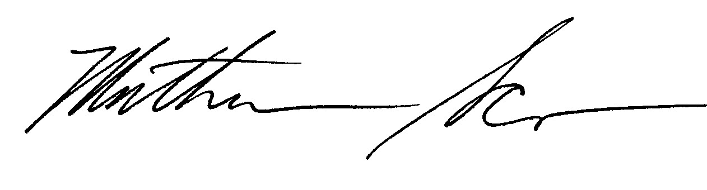
Mathew J. Scirè
Director
Financial Markets and Community Investment

Appendix I: Comments from the Department of

Appendix I: Comments from the Department ^{Housing and Urban Development}
of Housing and Urban Development

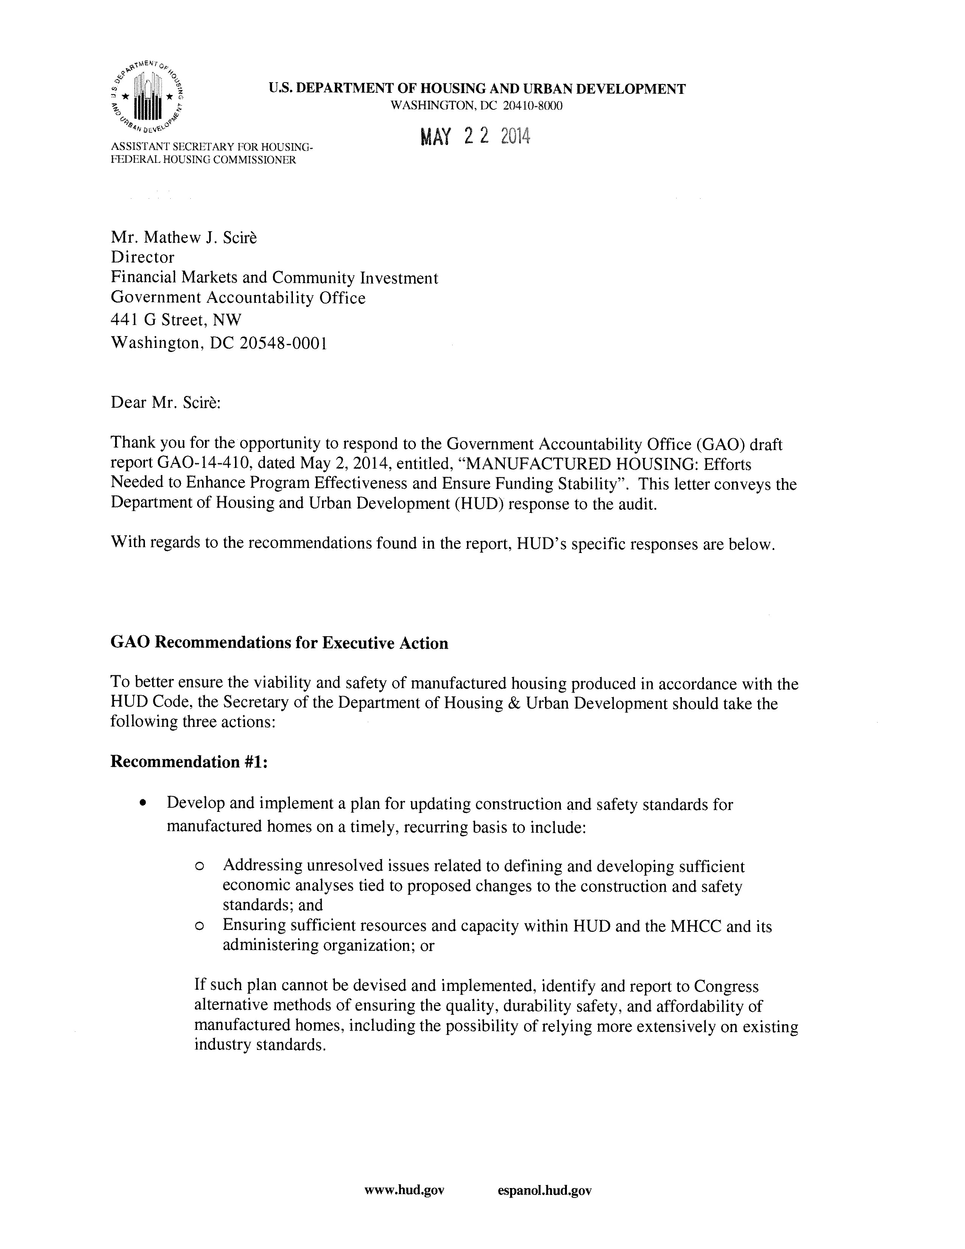

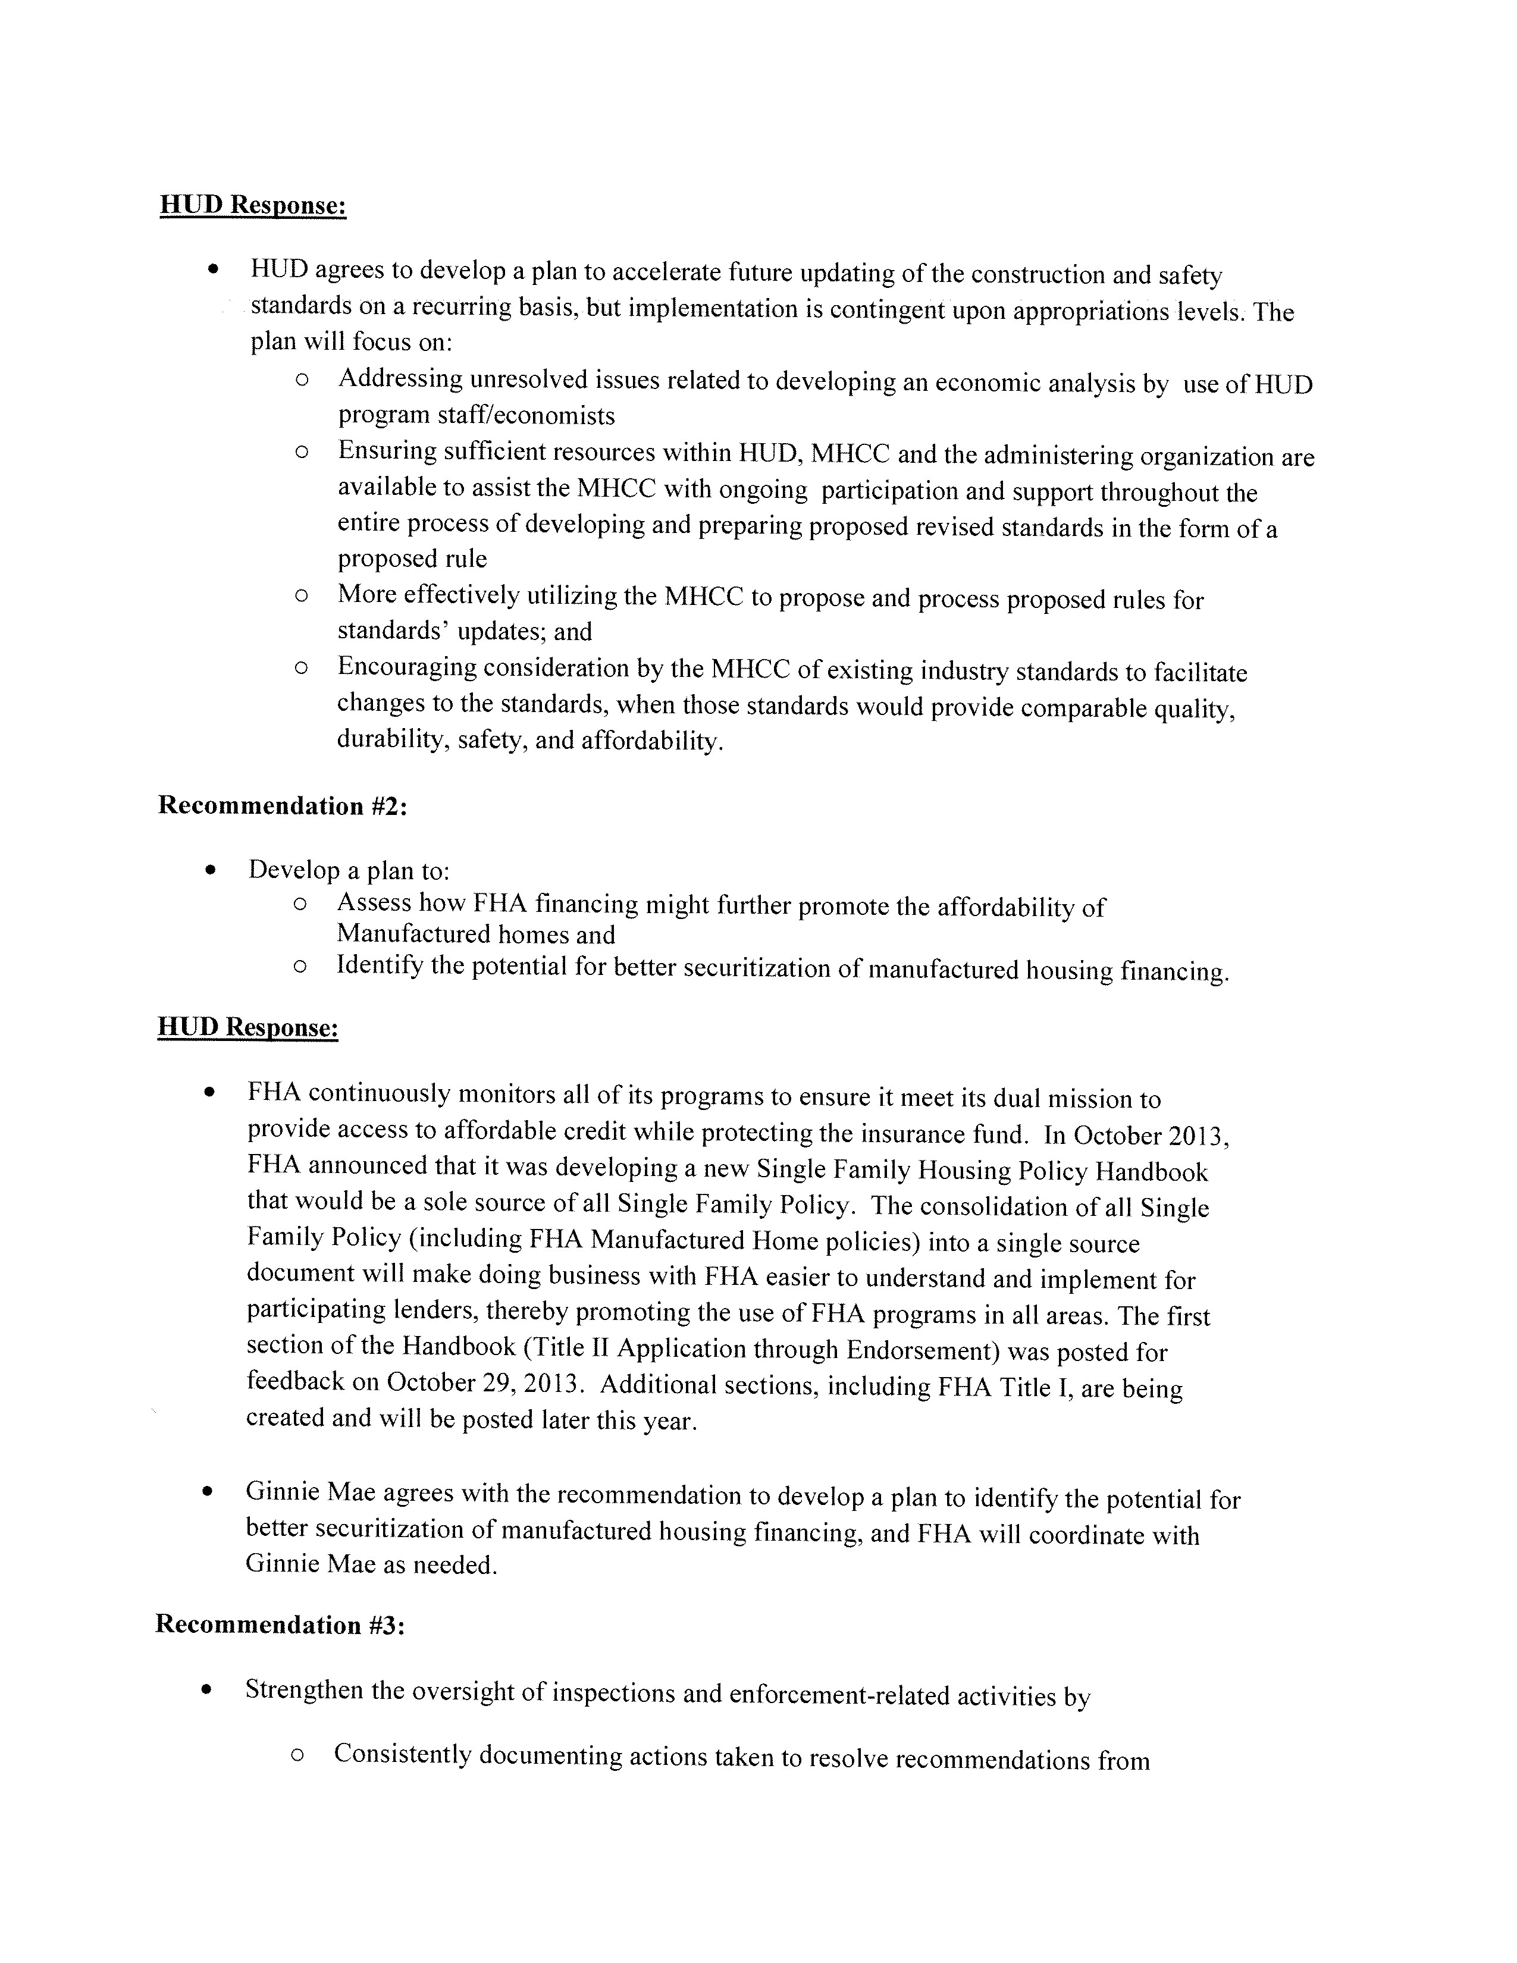

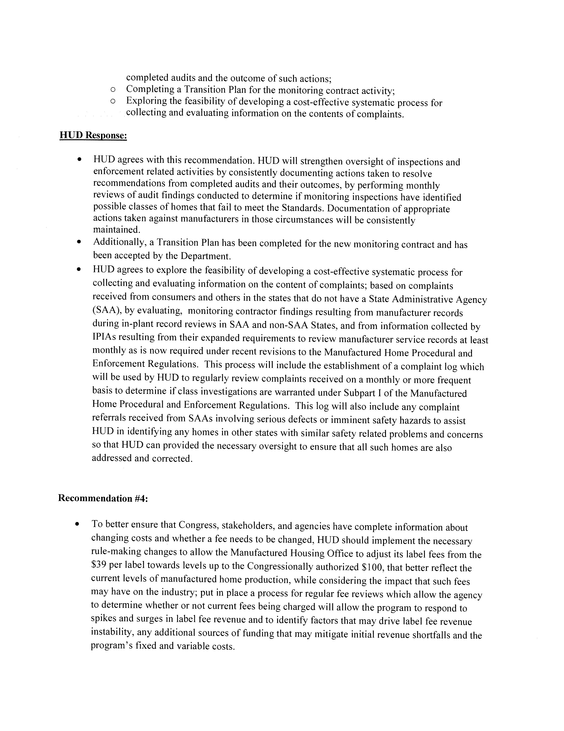

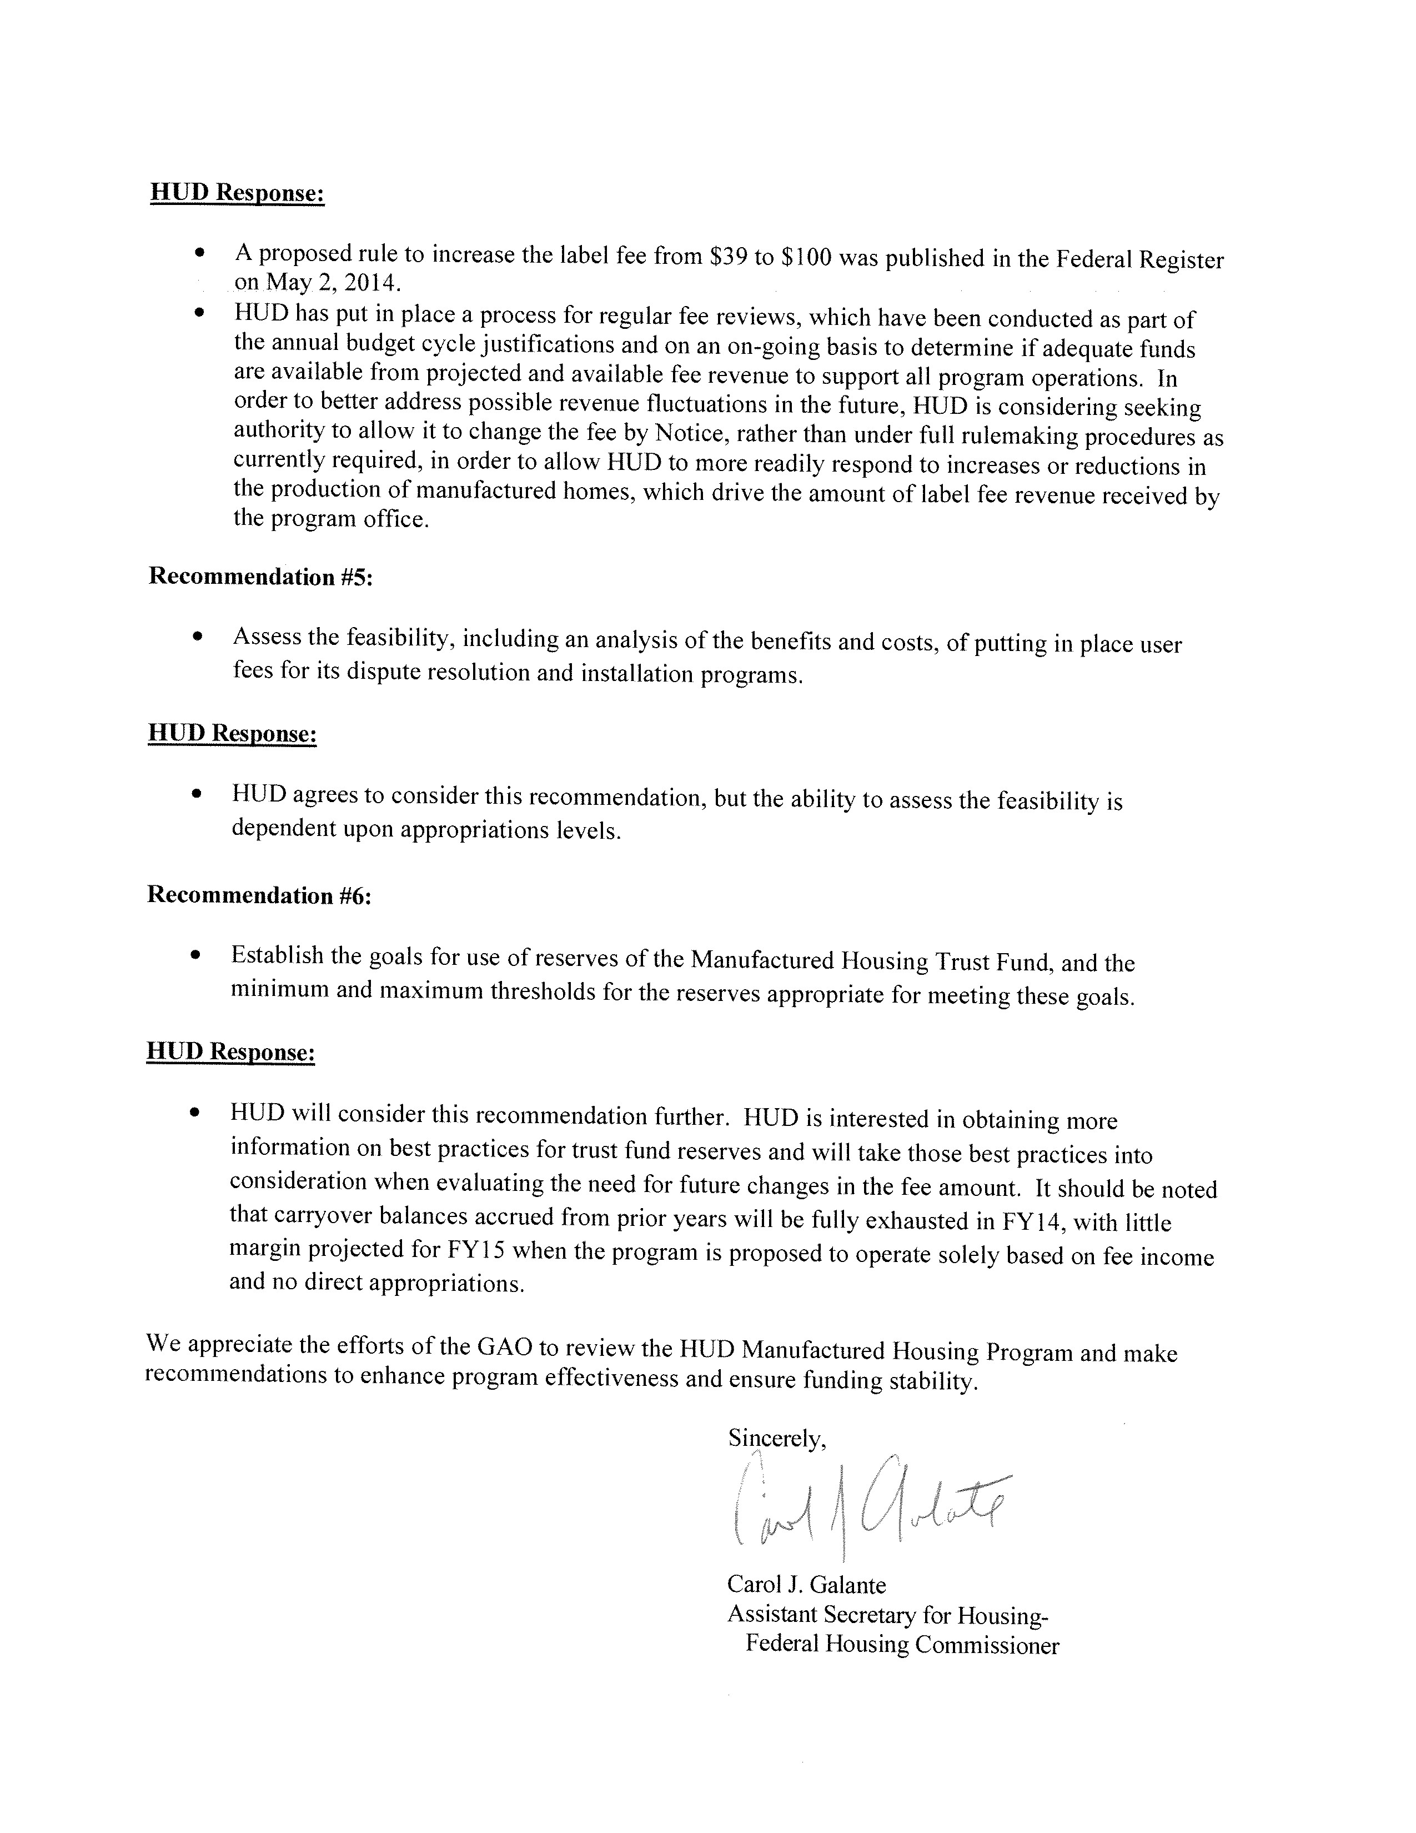

Appendix II: GAO Staff Contact and

Appendix II: GAO Staff Contact and ^{Acknowledgments}
Acknowledgments

GAO Contact Mathew J. Scirè, (202) 512-8678 or sciremj@gao.gov

Staff In addition to the contact named above, Andy Finkel (Assistant Director), Barry Kirby (Analyst in Charge), Tim Bober, Stephen Brown, Tarik Carter,
Acknowledgments Emily Chalmers, Pamela Davidson, Alexandra Edwards, Juliann Gorse,
Felicia Lopez, John McGrail, Marc Molino, Ruben Montes de Oca, Dae Park, Nadine Garrick Raidbard, Katherine Trimble, and James Vitarello made key contributions to this report.
(250698)

GAO’s Mission | The Government Accountability Office, the audit, evaluation, and investigative arm of Congress, exists to support Congress in meeting its constitutional responsibilities and to help improve the performance and accountability of the federal government for the American people. GAO examines the use of public funds; evaluates federal programs and policies; and provides analyses, recommendations, and other assistance to help Congress make informed oversight, policy, and funding decisions. GAO’s commitment to good government is reflected in its core values of accountability, integrity, and reliability.
Obtaining Copies of  GAO Reports and  Testimony | The fastest and easiest way to obtain copies of GAO documents at no cost is through GAO’s website (http://www.gao.gov). Each weekday afternoon, GAO posts on its website newly released reports, testimony, and correspondence. To have GAO e-mail you a list of newly posted products, go to http://www.gao.gov and select “E-mail Updates.”
Order by Phone | The price of each GAO publication reflects GAO’s actual cost of production and distribution and depends on the number of pages in the publication and whether the publication is printed in color or black and white. Pricing and ordering information is posted on GAO’s website, http://www.gao.gov/ordering.htm.  Place orders by calling (202) 512-6000, toll free (866) 801-7077, or TDD (202) 512-2537.  Orders may be paid for using American Express, Discover Card,  MasterCard, Visa, check, or money order. Call for additional information.
Connect with GAO | Connect with GAO on Facebook, Flickr, Twitter, and YouTube.  Subscribe to our RSS Feeds or E-mail Updates. Listen to our Podcasts.  Visit GAO on the web at www.gao.gov.
To Report Fraud,  Waste, and Abuse in  Federal Programs | Contact:  Website: http://www.gao.gov/fraudnet/fraudnet.htm E-mail: fraudnet@gao.gov  Automated answering system: (800) 424-5454 or (202) 512-7470
Congressional Relations | Katherine Siggerud, Managing Director, siggerudk@gao.gov, (202) 512-  4400, U.S. Government Accountability Office, 441 G Street NW, Room 7125, Washington, DC 20548
Chuck Young, Managing Director, youngc1@gao.gov, (202) 512-4800
Public Affairs
U.S. Government Accountability Office, 441 G Street NW, Room 7149 Washington, DC 20548

Please Print on Recycled Paper.

Pub. L. 106-569, Title VI. Page 1 GAO-14-410 Regulation of Manufactured Housing
GAO, Manufactured Housing Standards: Testing and Performance Evaluation Could Better Ensure Safe Indoor Air Quality, GAO-13-52 (Washington, D.C.: Oct. 24, 2012).
The Consumer Financial Protection Bureau (CFPB) recently published a Fact Sheet stating that it is considering changes to the reporting requirements for lenders under HMDA. One change under consideration is for lenders to report for manufactured housing loans the type of financing, such as chattel or mortgage loans, and whether the borrower will own or lease the land where the home is sited.
GAO, Federal User Fees: Fee Design Options and Implications for Managing Revenue Instability, GAO-13-820 (Washington, D.C.: Sept. 30, 2013) and Federal User Fees: A Design Guide, GAO-08-386SP (Washington, D.C.: May 29, 2008).
U.S.C. 5401et seq.
For the purposes of this report, a site-built home refers to houses that are constructed on a permanent foundation, built to state and local building codes, but does not include multifamily structures.
According to ICC, 43 states and the District of Columbia have adopted or based their own state site-built and modular home construction and safety codes on the ICC’s IRC. In the remaining 7 states, local counties or municipalities determine their own residential building standards. The IRC is updated every 3 years by the ICC. States and localities, however, are not required to adopt the codes produced by the ICC and independently decide which versions or parts of the IRC to adopt.
In some communities, the owners of the homes may collectively own the community real estate in the form of a cooperative.
The MHCC also recommends proposals for installation standards.
The Manufactured Homes Survey reports annual data for each calendar year instead of fiscal year.
We determined that a home was “non-metropolitan” if the home was located in an area (urban or rural) outside of metropolitan statistical areas.
We limited our analysis of 2011 AHS data, the most recent data available, to manufactured homes built after 1974, when HUD began regulating these units.
These figures refer to occupied housing units.
The average is based on the mean and is calculated as the total dollars of sales divided by the total number of houses sold.
The AHS defines monthly housing costs for owner-occupied units as “the sum of monthly payments for all mortgages or installment loans or contracts […], real estate taxes (including taxes on manufactured/mobile homes, and manufactured/mobile home sites if the site is owned), property insurance, homeowner association fees, cooperative or condominium fees, mobile home park fees, land rent, and utilities.” Energy efficiency, and the impact on utility bills, is another factor impacting the affordability of manufactured homes. See GAO, Green Affordable Housing: HUD Has Made Progress in Promoting Green Building, but Expanding Efforts Could Help Reduce Energy Costs and Benefit Tenants, GAO-09-46, (Washington, D.C.: Oct. 7, 2008). As of May 2014, the HUD Code has not been updated to include nearly all proposed energy efficiency improvements from the MHCC. 17 In non-metropolitan areas, where the majority of manufactured homes are located and monthly housing costs in general are lower, the majority of owners of manufactured homes still had lower monthly housing costs than other households. According to the 2011 AHS, 50.8 percent of owner-occupied manufactured homes located in non-metropolitan areas paid less than $500 in monthly costs, compared to 31.7 percent of single family detached homes and 36.7 percent of apartment renters.
We defined higher priced loans as 150 basis points or more above the current Freddie Mac 30-year fixed-rate mortgage at the time of loan origination.
There are three property types in HMDA, one-to-four family homes (excluding manufactured housing), manufactured housing, and multifamily. We calculated the share of manufactured housing loans to be the number of manufactured housing loans divided by the sum of one-to-four family home loans and manufactured housing loans since this most closely approximates the share of manufactured housing loans of single family homes as possible using HMDA data.
For the purposes of this report, a conventional loan refers to loans neither made by nor insured or guaranteed by the federal government.
The Senate report that accompanied the Act stated that the purpose of the legislation was setting up a process to update manufactured housing construction and safety standards on a timely basis.
Office of Management and Budget (OMB) Circular A-4 states that agencies must demonstrate the need for federal regulatory action, consider alternative approaches, and conduct benefit-cost and cost-effectiveness analyses.
According to HUD, at least part of the delay was attributable to a bid protest filed in connection with HUD’s process for awarding a new contract for an administering organization. The bid protest was resolved in HUD’s favor earlier this year. See International Code Council, B-409146, Jan. 8, 2014, 2014 CPD ¶ 26. On June 18, 2014, HUD awarded a new contract for a new administering organization.
If HUD determines that a standard is necessary in response to a public health or safety emergency, the agency may issue an order without the MHCC’s approval after a period of public comment.
U.S.C. 5403(a)(4)
MHCC members did not meet or propose standards since from October 2012 until June 2014. 27 OMB Circular A-4 provides guidance on conducting regulatory analysis, including the development of economic analysis.
The Consolidated Appropriations Act of 2014 stipulated that HUD must employ an administrator for the Office of Manufactured Housing within 120 days. Pub. L. 113-76, 128 Stat. 605. HUD selected an administrator on March 6, 2014.
GAO/AIMD-00-21.3.1.
GAO, Manufactured Housing Standards: Testing and Performance Evaluation Could Better Ensure Safe Indoor Air Quality, GAO-13-52 (Washington, D.C.: Oct. 24, 2012). Carbon monoxide detectors are not intended to be used as a measure of, or to test for, adequate indoor air quality but are a safety device to warn occupants in the event of a dangerous build-up of carbon monoxide gasses in the air.
GAO-13-52.
Title I also insures private lenders against loss on property improvement loans for single family homes, multifamily structures, and nonresidential buildings.
According to FHA officials, the Title II data on manufactured homes include modular homes.
In 2012, over 4,000 newly placed manufactured homes were not titled.
Ginnie Mae guarantees the performance of mortgage-backed securities, which are obligations of the issuers and are backed by mortgages insured or guaranteed by federal agencies, such as FHA, VA, or USDA’s Rural Housing Service. Ginnie Mae is a wholly owned government corporation within HUD.
Ginnie Mae began securitizing manufactured housing loans in the early 1970s. However, 12 Ginnie Mae issuers with $1.8 billion of securities backed by Title I loans defaulted between 1986 and 1988, and Ginnie Mae had to assume their portfolios, resulting in significant losses. From 1989 until 2010, Ginnie Mae imposed a moratorium on the acceptance of new issuers in the manufactured housing program to prevent further losses. According to Ginnie Mae officials, Ginnie Mae continued to experience issuer defaults during the moratorium, with the last one in 1997.
FHA insurance covers 90 percent of losses from defaulted Title I loans and up to 100 percent of losses from defaulted Title II loans.
Field Hearing before the Subcommittee on Housing, Insurance and Community Opportunity, Committee on Financial Services, U.S. House of Representatives, State of U.S. Manufactured Housing Industry, (Danville, VA: Nov. 29, 2011).
HMDA data do not include credit score information.
Additionally, the FHA Manufactured Housing Loan Modernization Act of 2008 required HUD to revise FHA’s Title I program. See Pub. L. 110-289, Division B §§ 2141-2150. HUD revised Title I to increase loan amount limits and amend credit underwriting requirements, among other changes. See Title I letters TI 481 and TI 484. Also, in response to the FHA Modernization Act, Pub. L. 110-289, Division B, §§ 2101 – 2133, HUD made manufactured homes eligible for Title II insurance if treated as real estate by the local authority, even if not treated as real estate for purposes of state taxation, as well as individual manufactured housing units in condominium projects. See Mortgagee Letter 2009-16. 41 HUD, PD&R, Regulatory Barriers to Manufactured Housing Placement in Urban Communities, (Washington, D.C.: January 2011).
From 1998 to 2008, PD&R coordinated the publication of studies on manufactured homes technology under the Partnership for Advancing Technology in Housing (PATH) program. The goal of the program was to accelerate the creation and use of technologies in order to improve the affordability, quality, durability, and environmental and energyefficiency of homes and some PATH studies focused on manufactured homes.
RHS loan guarantee programs are available to borrowers with new manufactured homes on permanent foundations but do not finance manufactured housing titled as personal property.
Pub. L. 110-289.
GAO/AIMD-00-21.3.1.
GAO/AIMD-00-21.3.1.
FAR 46.103(e).
A hinged roof allows for the construction of a steeper, higher pitched roof. For such a roof, setup and final construction occurs on-site instead of at the factory.
Homes that are certified as Energy Star must undergo quality assurance testing on-site to validate, among other things, whether the home was constructed tightly enough, to minimize air leaks, and with sufficient ventilation air flow to maintain sound indoor air quality. 52 HUD has issued a proposed rule to more fully address on-site construction activities and simplify current alternative construction procedures. 75 Fed. Reg. 35902 (June 23, 2010). As of May 2014, the proposed rule had not yet been issued as a final rule.
The Energy Star certification requires testing to ensure that the home is constructed with minimal air leakage and adequate whole-house ventilation. Such testing is also incorporated into the current IRC used for site-built homes.
GAO-13-52.
Revenue figures shown in current dollars (unadjusted for inflation), as we compared them to the corresponding obligations for each fiscal year.
Estimates for fiscal year 2014 are based on a proposed fee increase of $100 per label for 6 months. Without a fee increase, the program projects it would generate only $3.5 million in label fee collections.
Appropriations and carryover balances shown in current dollars (unadjusted for inflation), as we compared them to the corresponding obligations for each fiscal year.
Fiscal year 2013 projections do not assume an increase in the label fee.
Collected and anticipated fees shown in current dollars.
GAO/AIMD-00-21.3.1.
The same day in which the agency received a draft of this report for review and comment, HUD published in the Federal Register a proposed rule calling for the increase of label fees from the current $39 per unit fee to an amount anticipated to be no less than $95 and no more than $105. This proposed rule outlines HUDs plans to increase the label fee and HUD officials hope to have a final rule permitting this increase ready to be implemented at the end of 2014.
GAO-13-820, p. 18.
GAO-13-820, p. 41.
GAO-13-820, p. 25.
Any state that wishes to operate its own installation program must have state installation standards that provide at least the same protection provided by the federal installation standards. 42 U.S.C. § 5404(c)(2)(B)(3).
A state dispute resolution program must meet the requirements of the Act for operating in lieu of the HUD dispute resolution program. 42 U.S.C. § 5422(c)(12).
The same day in which the agency received a draft of this report for review and comment, HUD published in the Federal Register a proposed rule calling for the increase of label fees from the current $39 per unit fee to an amount anticipated to be no less than $95 and no more than $105. This proposed rule outlines HUDs plans to increase the label fee and HUD officials hope to have a final rule permitting this increase ready to be implemented at the end of 2014.

